What should I already know?
- The seven continents and five oceans.
- The names of some key rivers around the world including the Thames, Mersey and the Nile.
- The main environmental regions around the world
- The climate of places is affected by their location
- The effects of climate change and pollution on the Earth.
- Which goods some countries trade.
Vocabulary
Amazon | a South American river- the largest in the world
biodiversity | the variety of plants and animals on earth
biome | a natural area of the living world which has its own climate, vegetation and animals
climate | the general weather conditions that are typical of a place
climate change | changes in the earth’s climate, especially the gradual rise in temperature, as a result of human activity
climate zone | sections of the Earth that are divided according to the climate. There are three main climate zones; polar, temperate and tropical.
continent | a very large area of land that consists of many countries. Europe is a continent.
deforestation | if an area is deforested, all the trees there are cut down
distribution | delivering goods to a number of places
economy | a country's economy is the wealth that it gets from business and industry
export | to export products or raw materials means to sell them to another country
hemisphere | one half of the earth. The Northern Hemisphere is the half of the world North of the Equator; the South Hemisphere is half of the world South of the Equator
natural resources | the land, forests, energy sources and minerals existing naturally in a place that can be used by people
Palm oil | a yellow oil which comes from the fruit of certain palm trees and is used in making soap and sometimes as a fat in cooking
rainforest | biomes with high rainfall and warm temperatures
supply chain | the entire process of making and selling goods, including every stage from the supply of materials and the manufacture of the goods through to their distribution and sale
sustainability | to maintain at a steady level without exhausting natural resources or causing severe environmental damage
South America | a continent- South of North America and home to Brazil and the Amazon rainforest
trade | the activity of buying, selling, or exchanging goods or services
trade route | a route, often covering long distances, that is used by traders
tropics | parts of the world that lie between two lines of latitude, the Tropic of Cancer, 23½° north of the equator, and the Tropic of Capricorn, 23½° south of the equator.  The tropics have a humid climate, where the weather is hot and damp.
vegetation | plants, trees and flowers
Yew Tree Primary Academy – Geography
Theme: Central and South America | Year Group : 6 | Phase: Key Stage 2 | Strand: (A Non-European society that provides contrasts with British history; Locational Knowledge; Place Knowledge; Human and Physical Geography; Geographical Skills)
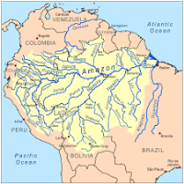
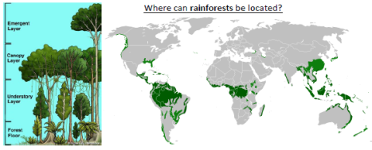

What Geographical skills will I have learnt by the end of this theme?
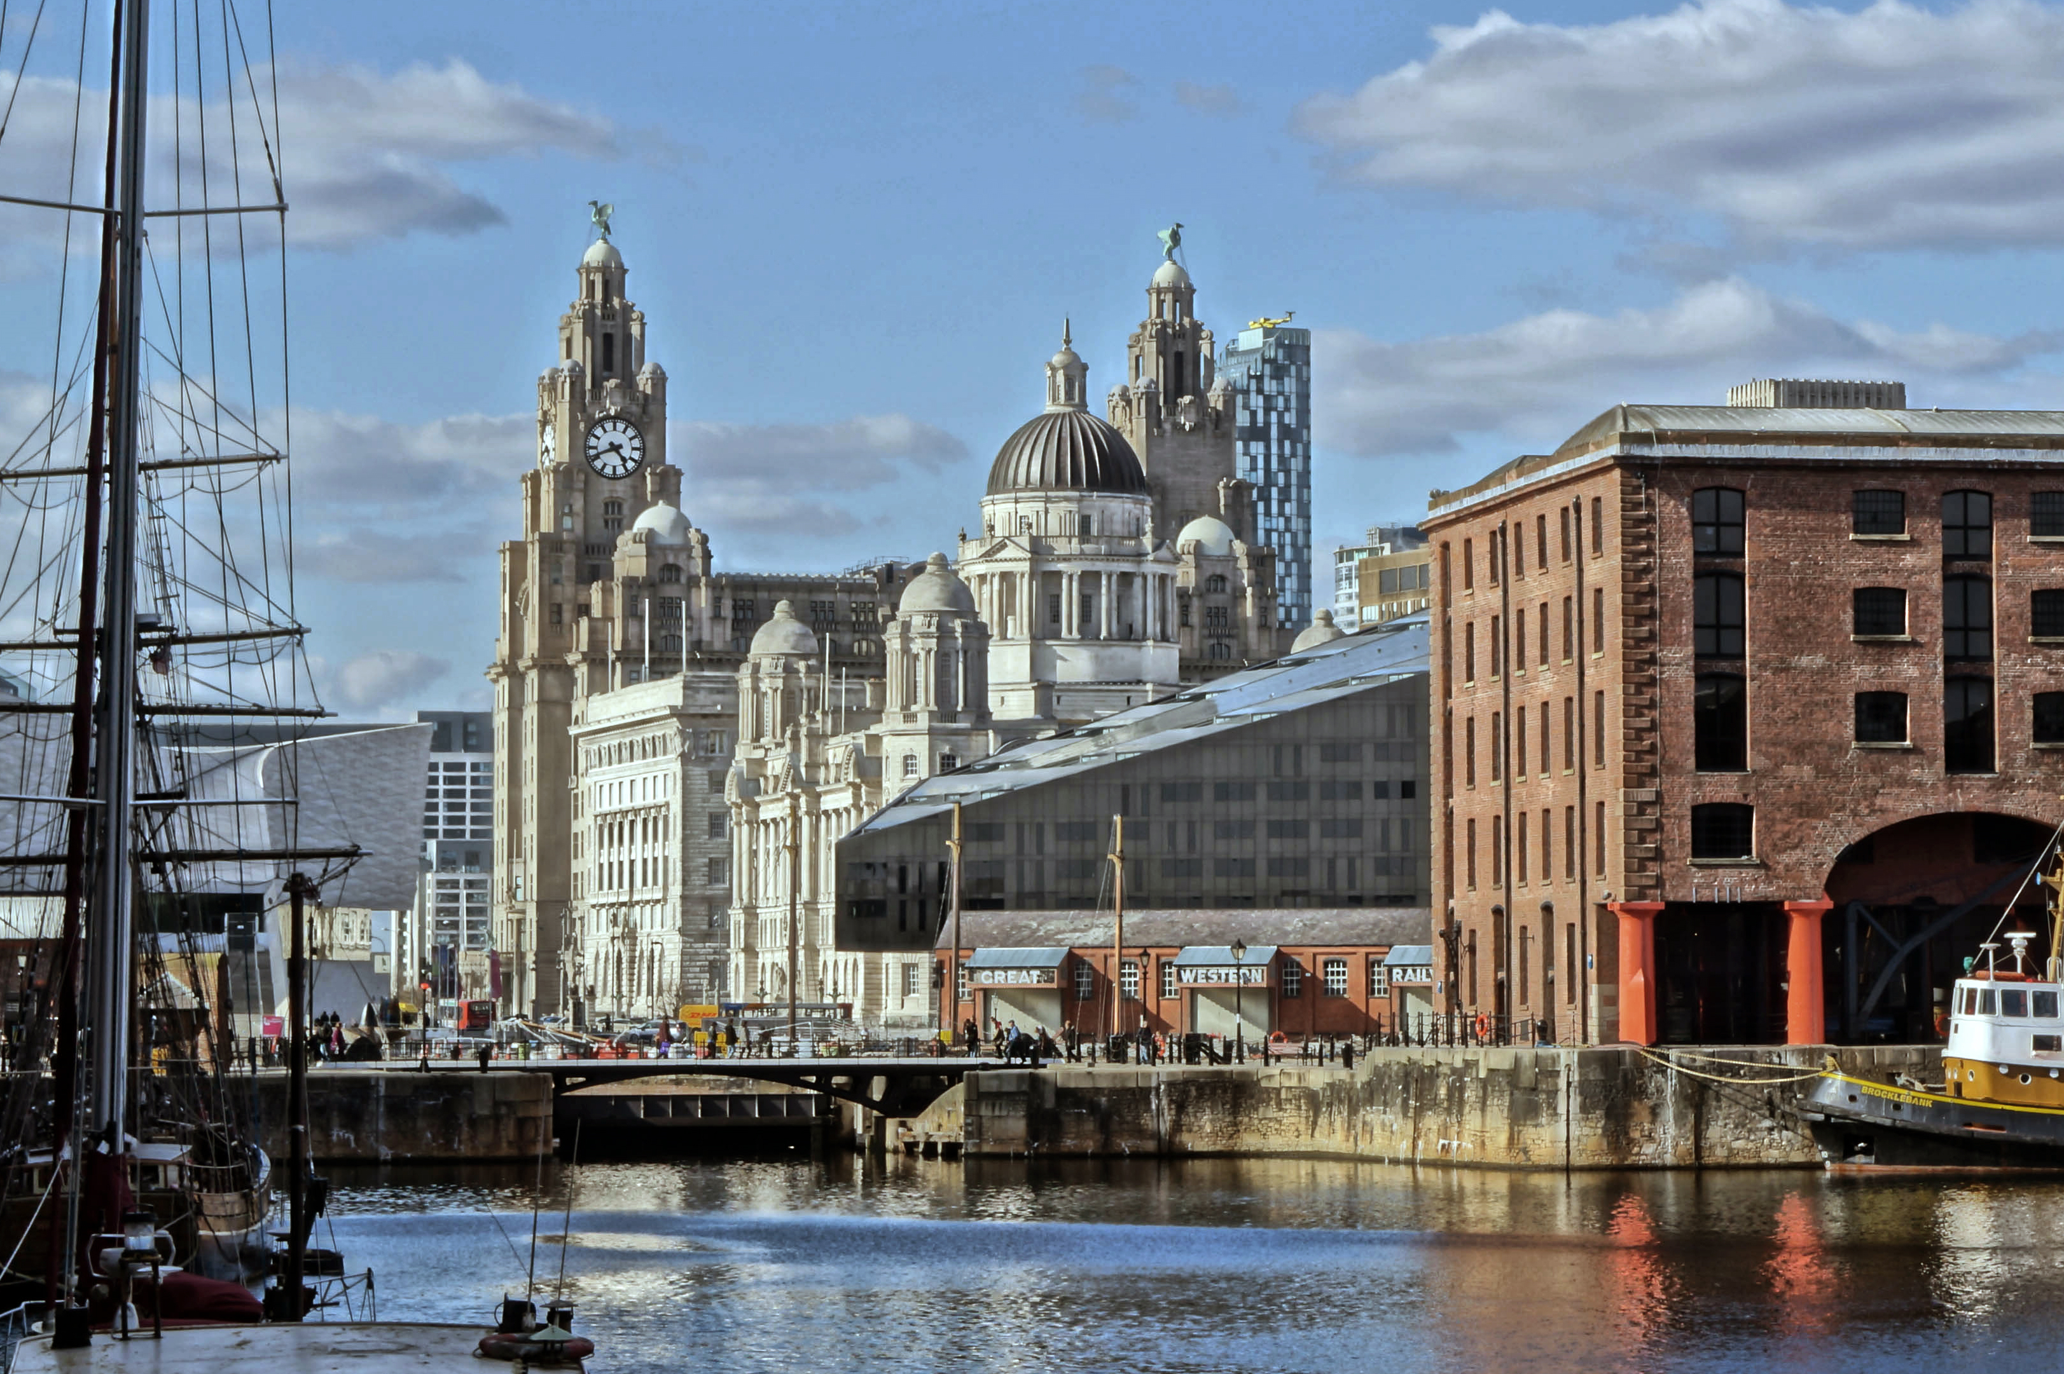
- Use atlases, maps and aerial photographs to locate world countries and major cities, before locating the countries and major cities in Central and South America.
- Use atlases, maps and aerial photographs to locate the world’s rainforests and explain what the climate is like there. Explain why rainforests cannot be found in the UK.
- Label the world’s biomes and vegetation belts
- Compare the average rainfall in different climate zones, including the rainforest, and draw a graph to represent this.
- Compare the sizes of different rainforests and represent them in a table.
- Explain how the vegetation and animal life changes in the different layers of the rainforest.
- Investigate the effects of climate change and pollution on rainforests. Use your knowledge to create a campaign to limit pollution and deforestation.
- Explain how deforestation can impact the Earth.
- Research trade routes from the UK, looking at key exports and imports.
- Investigate the natural resources, such as palm oil, that can be found in the rainforest and the role they play in trade routes.
- Describe the fair trade process for some products from the rainforest.
- Follow a product from the rainforest through the global supply chain.
- Explain sustainability and the role rainforests play.
- Explain why people have settled near the Amazon river
What Geographical Knowledge should I know by the end of this theme?
- The seven continents are: Africa, Asia, Antarctica, Australasia (Oceania), Europe, North America, South America
- Central America is home to Native Americans prior to Europe colonising the region.
- Central America was mainly colonised by Spain, therefore Spanish is still the most common language spoken
- The Amazon rainforest takes its name from Amazon, the world’s longest river
- Name and Locate some countries in Central and South America, and the Amazonian rainforest spans 9 countries: Brazil, Peru, Colombia, Ecuador, Bolivia, Venezuela, Guyana, Suriname and French Guiana
- Tropical rainforests are located in a band around the equator (Zero degrees latitude), mostly in the area between the Tropic of Cancer (23.5° N latitude) and the Tropic of Capricorn (23.5° S latitude). This 3,000 mile (4800 km) wide band is called the “tropics.” Tropical rainforests thrive here because of the hot and humid climates where it rains virtually every day.
- Rainforests cover just 6% of the Earth’s land surface, but are home to over 80% of known terrestrial species
- The rainforests are important because of the variety of life that they support (their biodiversity) and because they absorb carbon dioxide and release oxygen.
- The rainforest is under threat of deforestation because of: wood for both timber and making fires, agriculture for both small and large farms, pulp for making paper, road construction, extraction of minerals and energy.
- Brazil is the fifth largest country in the world, by both area and population - located in South America, the capital of Brazil is Brasilia. Other major cities are Sao Paolo and Rio de Janeiro.
- Brazil is the only country with the Equator and the Tropic of Capricorn passing through it.
Literacy Tree Links
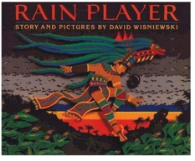

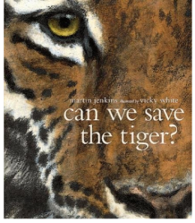

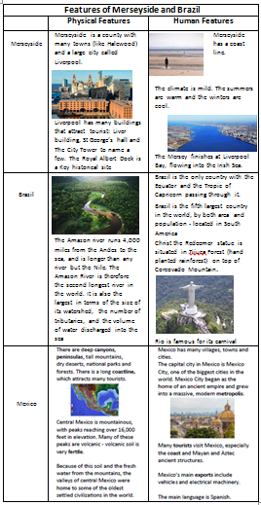
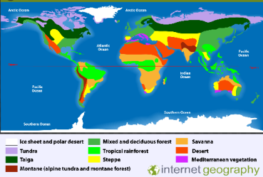
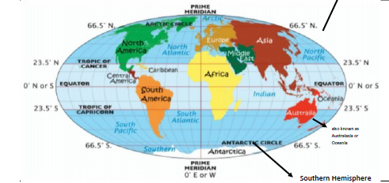
North Hemisphere

