|  |  |  |  |
| --- | --- | --- | --- |
| **Yew Tree Primary Academy – Geography** | | | |
| **Theme: London Calling** | **Year Group : 2** | **Phase: Key Stage 1** | **Strand: Human and Physical Geography** |

|  |
| --- |
| **What should I already know?** |
| * The town I live in is called Halewood. * Halewood is in England, which is a country in the United Kingdom (England, Scotland Wales and Northern Ireland). * Human features (houses, shops, parks, roads) and physical features (fields, woodlands) of Halewood * Great Britain (England, Scotland, Wales) is an island—it is surrounded by seas: Irish Sea, North Sea and English Channel |

|  |  |
| --- | --- |
| **Vocabulary** | |
| capital city | the city where the government sits. London is the capital city of England and the UK. |
| city | a large town. London is a city. |
| compass point | any of the main points of a compass: north, south, east and west |
| continent | a very large area of land that consists of many countries. Europe is a continent. |
| country | an area of land that is controlled by its own government. |
| England | a country in the United Kingdom. |
| forest | a large area where trees grow close together |
| Great Britain | An island that is made up of England, Scotland and Wales. |
| hill | a naturally raised area of land, which is not as high as a mountain. |
| human features | features of land that have been impacted by human activity |
| island | a piece of land that is completely surrounded by water |
| ocean | one of the five very large areas of salt water on the Earth's surface. |
| physical features | natural features of land |
| river | a large, natural stream of fresh water that flows into the sea or a lake |
| sea | a large area of salty water that is part of an ocean |
| skyscrapers | a very tall building with many floors |
| tourists | a person who is visiting a place for pleasure and interest, especially when they are on holiday. |
| town | a large group of houses, shops and buildings where people live and work. Towns are larger than villages but smaller than cities. Sudbury is a town |
| train station | a place on a railway line where trains stop for people to get on and off trains. |
| United Kingdom | The UK, is officially known as the United Kingdom of Great Britain and Northern Ireland. It includes England, Scotland, Wales and Northern Ireland. |
| vegetation | plants, trees and flowers |

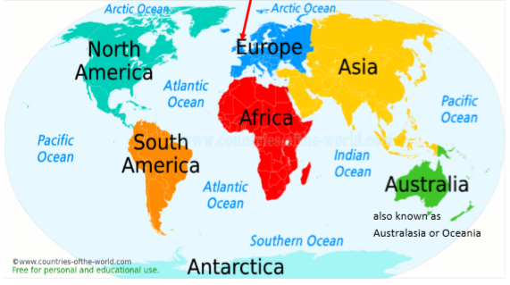

|  |
| --- |
| **What should I know by the end of this theme?** |
| * There are seven continents: Europe, Asia, Africa, North America, South America, Antarctica and Australia (also known as Australasia and Oceania) * There are five oceans: Pacific Ocean, Atlantic Ocean, Indian Ocean, Southern Ocean and Arctic Ocean * I know the UK is in Europe * I Know the countries in the UK and London is the capital city of England |

|  |
| --- |
| **What Geographical skills will I have learnt by the end of this theme?** |
| * Find the five oceans and seven continents using map skills. Can you also find them in an atlas and on a globe? * Use Google Earth to find Halewood. Zoom out until you see the UK. Now zoom out until you see Europe. Now zoom out until you can see the world. Discuss what you notice. * Use the compass points to describe the continents in relation to each other (e.g. Asia is to the east of Europe and to the north of Australia). * I can locate London on a map and identify key features. |

 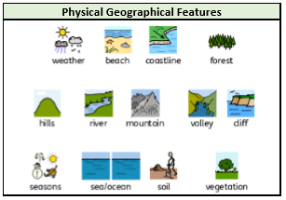

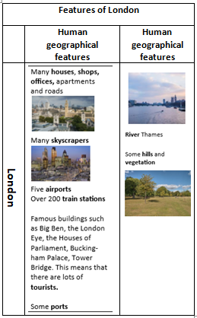

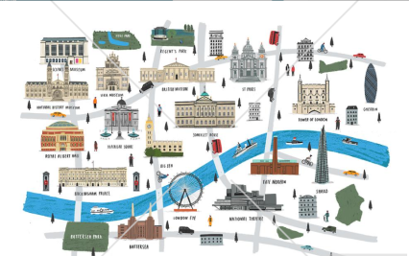

|  |
| --- |
| **Literacy Tree Links** |
|  |