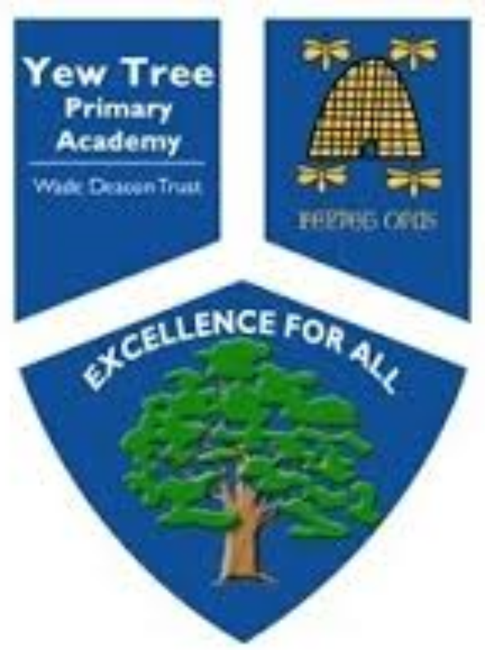
Yew Tree Primary Academy
Class___Elm____________
Remote Learning
W/C 18th January 2021

English
Writing:
Flotsam by David Wiesner
SPaG:
-er and -est suffixes
Geography
N/A
Reading
The Firework maker’s Daughter by Philip Pullman

PE
Yoga

Music
N/A

Elm Class
French
Colours
Number 11-20

History
What were the different periods in the Stone Age?
ne Age

Computing
Coding – Scratch Jr
Art and DT
Prehistoric palette

Maths
Multiplication and Division

Science
How do the rocks on our Earth's surface change?

Suggested Daily Timetable
Time | Lesson/Activity
9-9.20 or 20 minutes | Reading  Read something from your house. It can be a book, a magazine, something on your tablet. Complete daily reading lesson/task.
9.20-9.30 or 10 minutes | Tell somebody about what you have read. You could tell a family member or facetime a friend.
9.30-10 or 30 minutes | Maths Activity  Pick an activity to complete. If you finish quickly make up some sums for yourself or test yourself on what you have learnt.
10-10.15 or 15 minutes | Common Exception Words  Pick 5 to 10 words and try and memorise them words. You could write them down to try and help you remember them or get someone to test you on them afterwards
10.15-10.45 or 30 minutes | Break  Have a break and move around. Go outside do some exercise. Have some snack and a rest.
10.45-11.15 or 30 minutes | Spelling or Phonics Activity  Choose 5 or 10 spellings. Try to learn them. Look, Cover, Write, Check. Put them into a spoken sentence. Put them into a written sentence.
11.15-11.30 or 15 minutes | Arithmetic activity  Try and have a go at some of your time tables or numberbonds. You could also play on TTRS or some maths games on your tablet/phone or laptop.
11.30-11.45 | Movement break.  Put on go noodle and have a dance. Run around your garden or do some exercises.
11.45-12 or 15 minutes | Handwriting Activity  Practise some of the letters and words from your handwriting sheet.
12-1 or 1 hour | Lunch  Have your lunch. Go outside and get some fresh air or watch some TV and rela x.
1-1.30 or 30 minutes | Foundation Subject  Complete one of the activities for either Science, History, Geography, Art/DT, French, Computing or Music.
1.30-2 or 30 minutes | PE  Have a go at some of the PE links. Go in your garden and do some exercise. Play football or make an obstacle course.
2-2.30 or 30 minutes | Learning Tree (History and Geography)  You could create a poster around the topic that you have been learning- make it bright and colourful with lots of facts and drawings.  Choose an activity from the isolation planning.
2.30-2.50 or 20 minutes | Choosing Time  Play on your computer and tablet and can you challenge your friends to a TTRS battle
2.50-3.10 or 20 minutes | English Write in your isolation diary.  Think about what you have done today and write about it. You may want to add more later on when the day has nearly finished.

Yew Tree Primary Academy
Isolation Planning

Year 3
W/C 18th January 2021
Reading Tasks/Lessons  The Firework maker’s Daughter by Philip Pullman | Spelling/phonics Tasks/Lessons
Day 1- To engage with the text  In the lesson, we are going to engage with a new text and practise strategies for understanding unfamiliar vocabulary.  https://classroom.thenational.academy/lessons/to-engage-with-the-text-c9h3je | Day 1- Suffixes: -er and -est  To investigate suffixes: -er and -est suffixes  In this lesson, we will explore the rules associated with adding the suffixes -er and -est. 10 spelling words will be explained and set to learn.  https://classroom.thenational.academy/lessons/to-investigate-suffixes-er-and-est-suffixes-ccw32d
Day 2- To answer questions on text, orally and in written form  In this lesson, we will answer retrieval and inference questions.  https://classroom.thenational.academy/lessons/to-answer-questions-on-the-text-orally-and-in-written-form-c5jk6d | Day 2- To practise and apply knowledge of suffixes: -er and -est suffixes, including test  In this lesson, we will practise the rules associated with adding the suffixes -er and -est. We will learn how to practise using the colour blocking strategy and will test the words previously set to learn.  https://classroom.thenational.academy/lessons/to-practise-and-apply-knowledge-of-suffixes-er-and-est-suffixes-including-test-6gwkje
Day 3- To analyse a character  In this lesson, we will use inference questions to analyse the main character in the book.  https://classroom.thenational.academy/lessons/to-analyse-a-character-6wv3gd | Day 3- To investigate suffixes: More -er and -est suffixes  In this lesson, we will further explore the rules associated with adding the suffixes -er and -est. 10 spelling words will be explained and set to learn.  https://classroom.thenational.academy/lessons/to-investigate-suffixes-more-er-and-est-suffixes-6rv6at
Day 4- To explore one of the main themes  In this lesson, we will explore one of the main themes of the book.  https://classroom.thenational.academy/lessons/to-explore-one-of-the-main-themes-6dk30d | Day 4- To practise and apply knowledge of suffixes: More -er and -est, including test  In this lesson, we will be further practising and applying knowledge of the rules used when adding the suffix -er and -est.https://classroom.thenational.academy/lessons/to-practise-and-apply-knowledge-of-suffixes-more-er-and-est-including-test-c8w64r
Day 5- To explore genre  In this lesson, we will analyse the genre of the book.  https://classroom.thenational.academy/lessons/to-explore-genre-6rr32t | Day 5 – Applying suffixes in context  Write 5 sentences using a different -er suffix in each one. Underline the suffixes in your sentences.  Write 5 sentences using a different -est suffix in each one. Underline the suffixes in your sentences.
Writing Tasks/Lessons  Flotsam week 2 (Lessons 5 -10) | Maths Tasks/lessons  Multiplication and division
Day 1- Flotsam Lesson 6  LO: I can use my storyboard to write a story with six paragraphs.  I can use adverbials to build up descriptions in my story writing. | Day 1- Multiplying by 8  LO: To be able to recall and use the 8 times table.
Day 2- Flotsam Lesson 7  LO: I can plan a story  I can uplevel my sentences by using adverbials to join ideas in my story. | Day 2- Multiplying by 8  LO: To be able to recall and use the 8 times table.
Day 3- Flotsam Lesson 8  LO: I can use my plan to write section one and section two of my story. | Day 3- Dividing by 3  LO: To be able to use the 3 times table for division.
Day 4- Flotsam Lesson 9  LO: I can write the next section of my story, using building blocks for descriptive sentences. | Day 4- Dividing by 4  LO: To be able to use the 4 times table for division.
Day 5- Flotsam Lesson 10  LO: I can publish my story, finding synonyms to vary and uplevel vocabulary used in my plan. | Day 5- Multiplying and dividing  LO: To be able to understand the relationship between multiplication and division.

Science Tasks/Lessons  Chemistry- Rocks and Soils | Learning Tree (History or Geography) Tasks/lessons  Stone Age to Iron Age
Day 1-  How do the rocks on our Earth's surface change?  In this lesson, we will learn how rocks change. We will look at rocks as big as mountains and as small as a grain of sand and learn the processes that form each. We will look at erosion, weathering and the movements of tectonic plates. You will need a piece of paper and a pencil for this lesson.  https://classroom.thenational.academy/lessons/how-do-the-rocks-on-our-earths-surface-change-65jkjt | Day 1- What were the different periods in the stone age?  https://classroom.thenational.academy/lessons/what-were-the-different-periods-in-the-stone-age-crtkad

Foundation Subjects (if applicable for this term)
PE –Yoga

Warm up - Super Mood Mover
https://www.bbc.co.uk/teach/supermovers/pshe-super-mood-movers-wellbeing/zpxc3j6

Cosmic Yoga

https://www.youtube.com/watch?v=U9Q6FKF12Qs&list=PL8snGkhBF7ngiFwW6-b9aV5eCgY0FAAB4

Art – Prehistoric palette

https://www.kapowprimary.com/subjects/art-design/lower-key-stage-2/year-3/prehistoric-art/lesson-3-prehistoric-palette-free-lesson/

French - (See attachments)

Number 11-20
Colours

Computing – Coding Scratch JR (Download Scratch Junior app for free)
Lesson 1 - https://www.youtube.com/watch?v=MzEh2_M2SqI
See Activity sheet – Can I make my car drive across the city?

PSHE- This allows the children to reflect on the impact of COVID.
https://www.storicise.com/?fbclid=IwAR1qTLlhosHO0-17agxjYpOOPrRlCGjPZSa_MUmFKDx3ZxiP5IAcPCi0T9Y
RE- Why is the Bible a best seller? (See powerpoint).

Staying Safe Online
Additional learning resources parents may wish to engage with
add and take away depending on year group.
- BBC Bitesize - Lots of videos and learning opportunities for all subjects.
- Classroom Secrets Learning Packs - Reading, writing and maths activities for different ages.
- Twinkl - Click on the link and sign up using your email address and creating a password. Use the offer code UKTWINKLHELPS.
- White Rose Maths online maths lessons. Watch a lesson video and complete the worksheet (can be downloaded and completed digitally).
- Times Table Rockstars. Your child can access this programme with their school login. On Times Table Rockstars, children should aim to play Soundcheck for 20 minutes daily.
- IXL online. https://uk.ixl.com/
- Mastery Mathematics Learning Packs. Take a look at the mastery mathematics home learning packs with a range of different activities and lessons.
- Talk4writng - https://www.talk4writing.com/wp-content/uploads/2020/06/Y3-Unicorn-F.pdf an excellent resource to support your child’s speaking and listening, reading and writing skills.

Printable sheets/resources:

Spelling

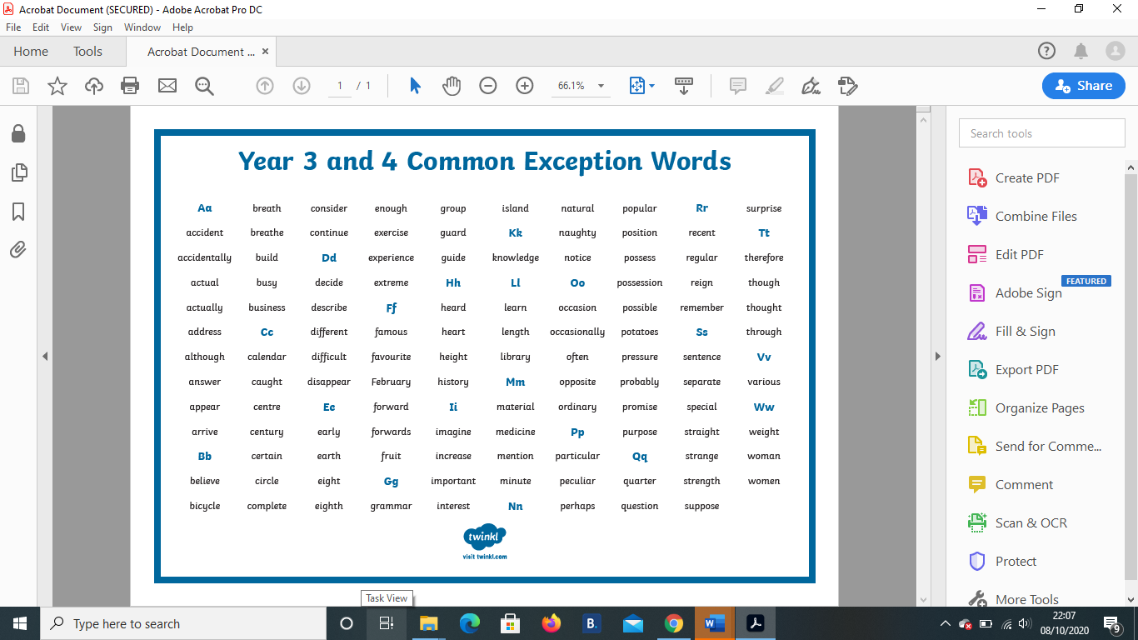

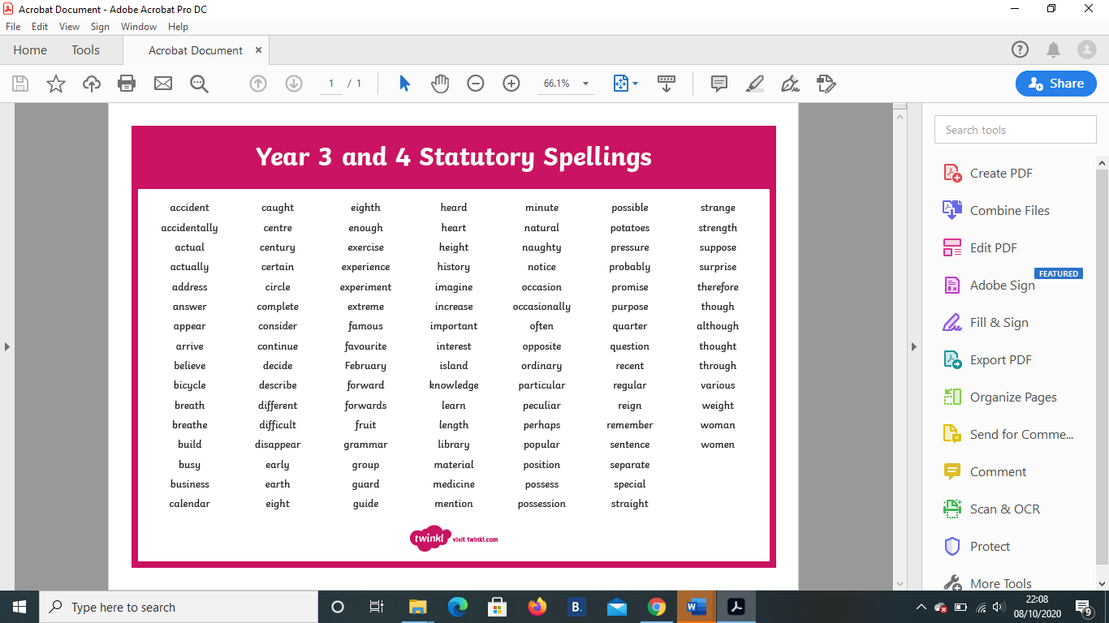

Handwriting Daily Year 3 statutory spellings and handwriting

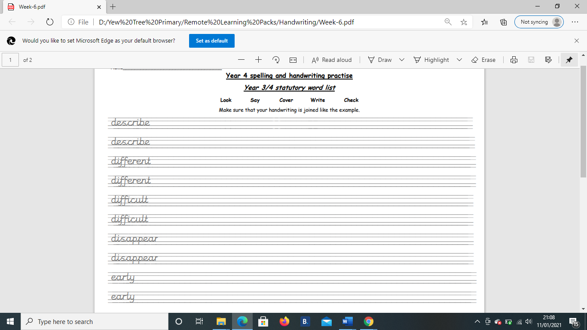

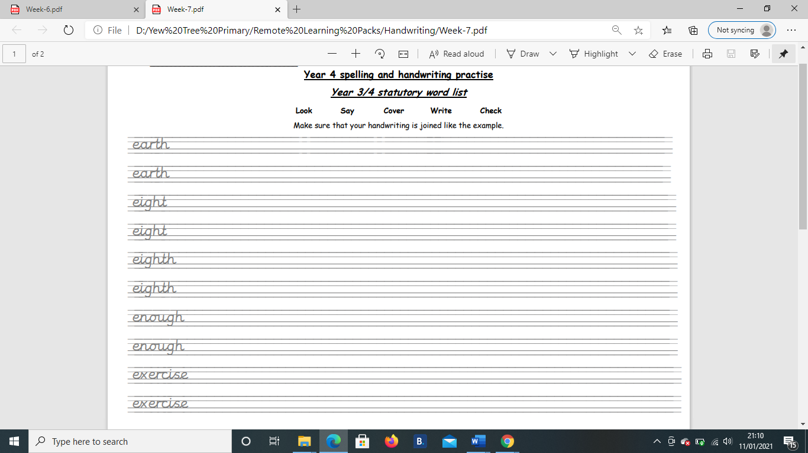
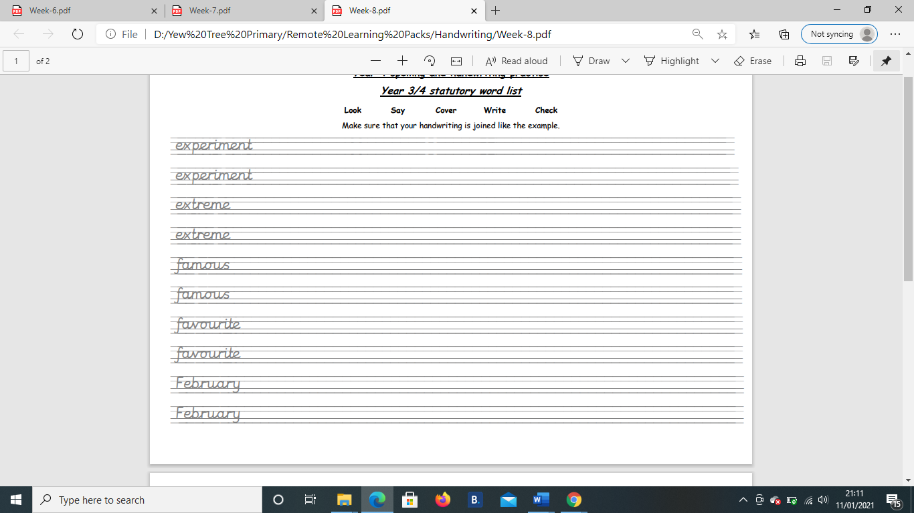
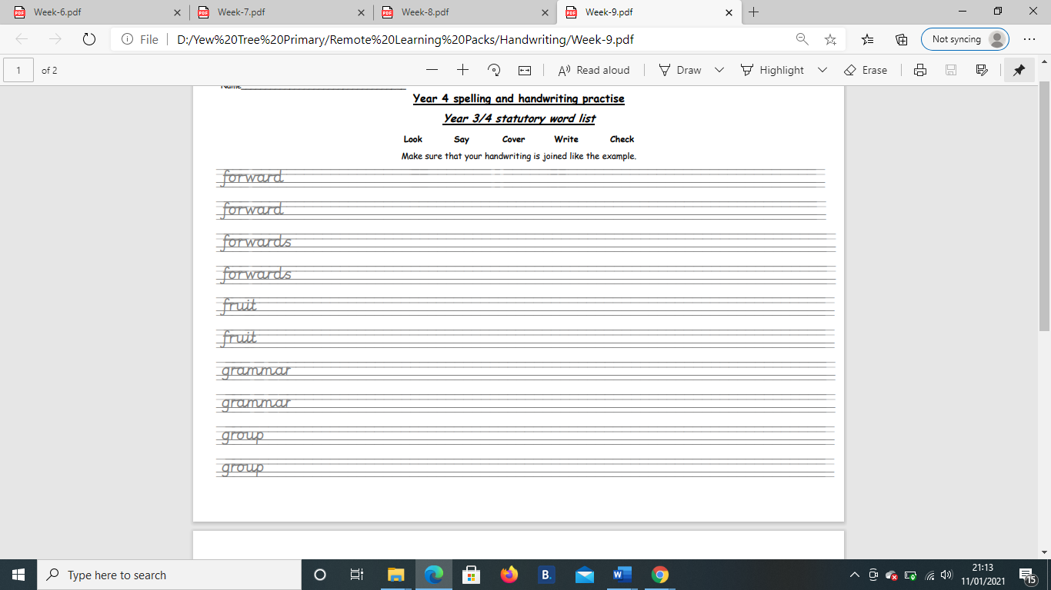
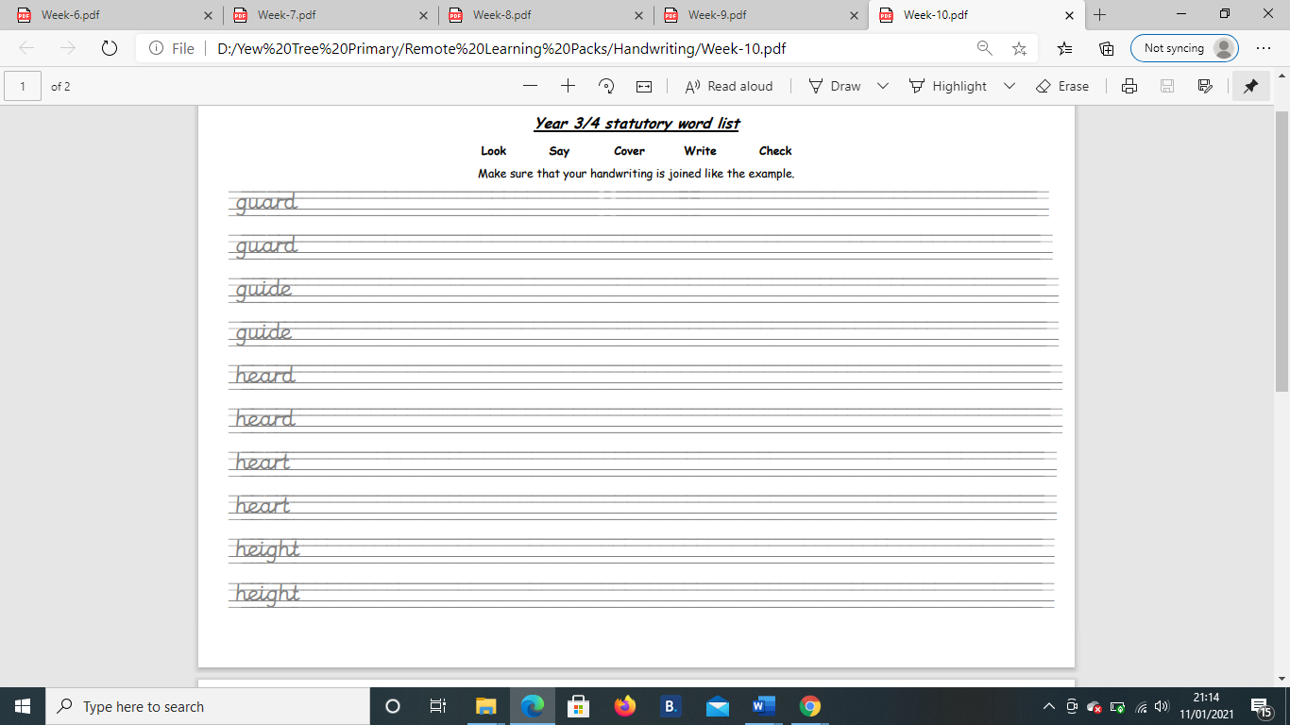
Arithmetic
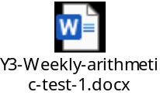 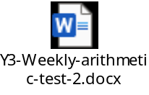 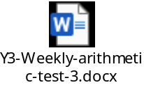 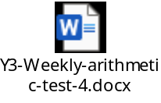 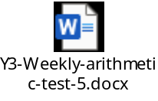 (Sheets will be uploaded on Class Dojo daily).

