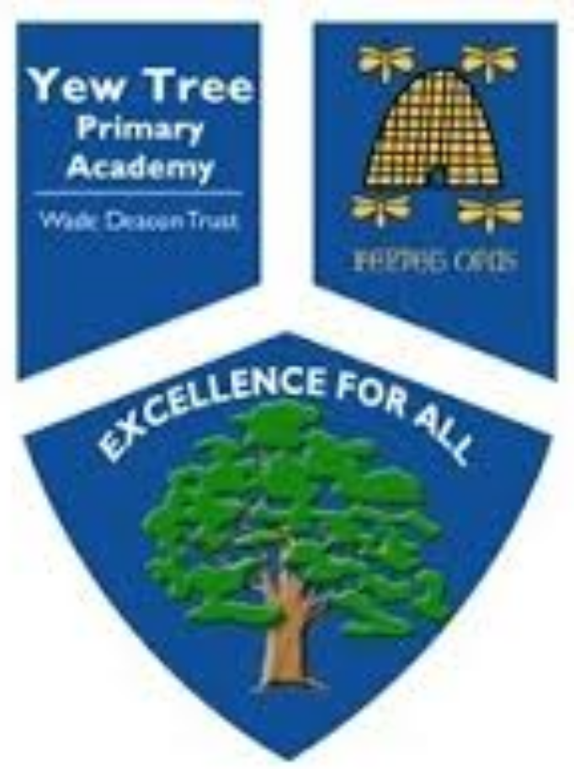
Yew Tree Primary Academy
Class Willow
Term Spring 1

January 11th- January15th 2021

English
Writing:

SPaG:

Homophones
Y6 Word list words
Reading

There’s A Boy in the Bathroom
Daily Reading

Willow
Music
Pulse and Rhythm
4 Beats in a Bar

Geography
South America

PE
Fitness

Computing

Web Creation

Maths

Decimals
4 A Day
TT Rocktars
French
Family
Daily Routine

Science

Electricity

RE
Big life questions and Faith’s answers to them

Art
Portraits

Suggested Daily Timetable
Time | Lesson/Activity
9-9.20 or 20 minutes | 4ADAY  4 Daily maths questions to complete
9.20-9.30 or 10 minutes | Reading- Read a book for 10 minutes.
9.30-10 or 30 minutes | Maths Activity  Follow each daily lesson objective in order of the days. There is a sequence for you to follow. If you have missed a lesson, please still follow in the right order.
10:-10:30 or 30 minutes | English Reading Comprehension lesson  Follow the lessons in order as all of the lessons are in a sequence
10.30-11 or 30 minutes | Break  Have a break and move around. Go outside do some exercise. Have some snack and a rest.
11- 11:45 or 45minutes | English Writing Session  Follow the lessons in order as all of the lessons are in a sequence
11:45-12 or 15 minutes | English Spelling Session
12-12:45 or 45 minutes | Lunch  Have your lunch. Go outside and get some fresh air or watch some TV and relax.
12:45-1:30 or 45 minutes | Foundation Subject  Complete one of the activities for either Science, Geography, Art, French, Computing, Music , RE or PE
1:30 – 2:00 or  30 minutes | PAG  Follow the lessons in order as all of the lessons are in a sequence
2:00- 2:30 or  30 minutes | TT ROCKSTARS-  Practice those tables it’s so important!
2:30- 3:00 or  30 minutes | Reading  Choose a book and a quiet place to read

Yew Tree Primary Academy
Online Learning Planning

Willow
Week 1
Reading Tasks/Lessons | Grammar, Punctuation and Spelling Task
Day 1- To explore Bradley further  https://classroom.thenational.academy/lessons/to-explore-bradley-further-c9k38d | Day 1-  YEAR 6 SPELLINGS  Set words for spelling test. Tell children to ask a parent/carer to test them on Friday and let us know their score.  Words for this week:  appreciate government guarantee occur opportunity recognise  Look at online dictionary definitions of these words and write these definitions down.
Day 2-  To explore a theme  https://classroom.thenational.academy/lessons/to-explore-a-theme-c8vkgt | Day 2-  Year 6 Spellings  To investigate homophones  https://classroom.thenational.academy/lessons/to-investigate-homophones-6wuk6c
Day 3-  To identify features of a non-fiction text.  https://classroom.thenational.academy/lessons/to-identify-features-of-a-non-fiction-text-c8v32d | Day 3-  LO: To match and write definitions  Hers, heard  Aloud, allowed  Descent, dissent  Stationary, stationery  Draught, draft  Children are to write definitions for both
Day 4- To answer questions on a non-fiction text (Part 1)  https://classroom.thenational.academy/lessons/to-answer-questions-on-a-non-fiction-text-part-1-c9gp4d | Day 4-  LO: To revise my spellings  Children to revise all homophone words and words learnt on Day 1
Day 5-  To answer questions on a non-fiction text (Part 2)  https://classroom.thenational.academy/lessons/to-answer-questions-on-a-non-fiction-text-part-2-ctj30t | Day 5-  Spelling test  Teacher to provide a PP with voice recording of the spellings and then the answers as well.
Writing Tasks/Lessons | Maths Tasks/lessons
Day 1-  LO: To explore word classes and to answer meaningful questions.  https://player.vimeo.com/play/1724563372?s=403278410_1610058799_3ff30e23d380caa7df343fc43637bcb0&loc=external&context=Vimeo%5CController%5CApi%5CResources%5CUser%5CAlbum%5CVideosController.&download=1&filename=The%2BPromise%2BSession%2B1164.mp4 | Day 1-  To be able to multiply and divide numbers by 10, 100 and 1000 giving answers up to three decimal places.
Day 2-  LO : to build vocabulary through Synonyms  https://player.vimeo.com/play/1725332899?s=403429470_1610058858_064946f85e67ff5ef5e408dcfd8f6814&loc=external&context=Vimeo%5CController%5CApi%5CResources%5CUser%5CAlbum%5CVideosController.&download=1&filename=The%2BPromise%2BSession%2B2175.mp4 | Day 2-  To be able to associate a fraction with division and calculate decimal fraction equivalents for a simple fraction.
Day 3-  LO; To explore noun phrases  https://player.vimeo.com/play/1725198230?s=403391473_1610058858_7e21eee5570941a3ddd522c02b9c5325&loc=external&context=Vimeo%5CController%5CApi%5CResources%5CUser%5CAlbum%5CVideosController.&download=1&filename=The%2BPromise%2BSession%2B3139.mp4 | Day 3-  To be able to associate a fraction with division and calculate decimal fraction equivalents for a simple fraction.
Day 4-  LO: To explore metaphors, similes and personification to use figurative language  https://vod-progressive.akamaized.net/exp=1610022147~acl=%2A%2F1724441062.mp4%2A~hmac=976846d7456962f0474392545553720685561295f451121d669c72f940a19009/vimeo-prod-skyfire-std-us/01/654/16/403274761/1724441062.mp4?download=1&filename=The+Promise+Session+4.mp4 | Day 4-  To be able to associate a fraction with division and calculate decimal fraction equivalents for a simple fraction.
Day 5-  LO: To focus on personification.  https://player.vimeo.com/play/1725613619?s=403482005_1610058858_8867e167e3197e1b1e67e539c40f79a1&loc=external&context=Vimeo%5CController%5CApi%5CResources%5CUser%5CAlbum%5CVideosController.&download=1&filename=The%2BPromise%2BSession%2B5174.mp4 | Day 5-  To be able to multiply 1-digit numbers with up to two decimal places by 1-digit whole numbers, without regrouping.

Science Tasks/Lessons | Learning Tree Tasks/lessons
Day 1- | Day 1- Learning Tree  LO: To explore the countries of South America and justify my viewpoints  https://drive.google.com/file/d/15ouDxKLleL8UtVcR8mUQItZEAjmxW1sk/view?usp=sharing  https://school-learningzone.co.uk/key_stage_two/ks2_geography/south_america/south_america.html
Day 2- What are the different components in an electrical circuit?  https://classroom.thenational.academy/lessons/what-are-the-different-components-in-an-electrical-circuit-cdk34d | Day 2-
Day 3- | Day 3-  Learning Tree  LO: To explore the region of Central America  https://www.ducksters.com/geography/centralamerica.php
Day 4- | Day 4-
Day 5- | Day 5-

Foundation Subjects
PE

https://www.getset4pe.co.uk/resourcebank/viewresourcefile?id=11649

Art

https://www.accessart.org.uk/making-layered-portraits-part-one/

French
Family
https://drive.google.com/file/d/1eu9JhmmfJ1EVQmPS00q5OFkfRvYuD6-5/view?usp=sharing

RE
What is Human?
https://classroom.thenational.academy/lessons/what-is-a-human-c9j68d

Computing
Communication

https://classroom.thenational.academy/lessons/how-would-you-lay-out-your-web-page-6djp2t

Additional Learning Resources
- BBC Bitesize - Lots of videos and learning opportunities for all subjects.
- Classroom Secrets Learning Packs - Reading, writing and maths activities for different ages.
- Twinkl - Click on the link and sign up using your email address and creating a password. Use the offer code UKTWINKLHELPS.
- White Rose Maths online maths lessons. Watch a lesson video and complete the worksheet (can be downloaded and completed digitally).
- Times Table Rockstars. Your child can access this programme with their school login. On Times Table Rockstars, children should aim to play Soundcheck for 20 minutes daily.
- IXL online. Click here for Year 5 or here for Year 6. There are interactive games to play and guides for parents.
- Mastery Mathematics Learning Packs. Take a look at the mastery mathematics home learning packs with a range of different activities and lessons.
- Y5 Talk for Writing Home-school Booklets and Y6 are an excellent resource to support your child’s speaking and listening, reading and writing skills.

Spelling list underneath
Handwriting paper underneath




