Thy

**Reading at Home**

**Reading** – The children will have a home school reading books and reading record. They should read a minimum of 3 times per week and an adult should record this in their reading records.

Books are to be brought into school on their reading day. This can be found on the front of their school reading book folder.

If you have any queries, please speak to a member of staff.

**Physical Education**

In Spring, 1 PE will be on Wednesday.

In Spring 2, PE will be on Friday.

**Term Dates**

Spring Term 1 begins

Monday 8th January 2024

Break Up for February Half Term

Friday 19th February 2024

Spring Half Term 2 begins

Monday 20th February 2024

Break Up for Easter

Thursday 28th March 2024

Summer Term Begins Monday 15th April

|  |  |  |
| --- | --- | --- |
|  | **Learning** | |
| Literacy | The children have daily Literacy lessons. This half term our focused books are ‘The Magic Paintbrush and ‘Super Milly’. Our focused texts for Spring 2 are, ‘The Tiny Seed’ and ‘The Extraordinary Gardener’. The children will be encouraged to answer questions about the story showing their comprehension and understanding of what we are reading. They will also take part in small group activities based on the stories we are reading. This half term these activities will include writing lists and simple sentences.  The children also have daily phonics sessions where they learn new sounds and learn how to read words that include the new sound they have been taught. They are also listened to read during these sessions. They home school reading book matches their phonics level and what books they are reading in school. | |
| Maths | During Spring 1 we will be focusing on 2D & 3D shapes, lengths, heights, weight and capacity. The children will continue to have a daily number and counting inputs too! In Spring 2 we be learning about doubling and halving up to 10. We will also build on our previous learning of addition and subtraction to consolidate this, moving on to working with numbers bigger than 10. | |
| Communication and language | | There will be a strong focus on learning new vocabulary and the children will be encouraged to use this throughout their learning and play. The children will also participate in circle time sessions allowing them to share their thoughts and opinions as well as develop their ability of articulating longer sentences. |
| Physical Development | | During PE the children will be practicing their ball skills including throwing, catching, rolling, bouncing, dribbling and kicking. In Spring 2 we will be focusing on games in PE which include using many of the skills the children will have learnt in Spring 1. |
| Personal Social and Emotional Development | | During Spring 1 we will be looking at our ‘Dreams and Goals’. Looking at having a positive attitude, being resilient, not giving up easily and how we can help each other. In Spring 2 we learning about ‘Healthy Me’. This will include learning about healthy food choices, a balanced diet, personal hygiene and physical exercise. |
| Understanding the World | | During Spring term, the children will be looking at how they have grown and changed since being a baby. They will create their own personal timeline of them from a baby till now. During Science we will be looking at animals and their habitats. |
| Expressive Arts and Design | | They will sing familiar songs and nursery rhymes; moving melody and singing the pitch of a tone sung by another person (‘pitch match’). They will begin to respond to what they have heard, expressing their thoughts and feelings. During Art they will be learning about printing, rubbing and collage. In design and technology, we will be learning about healthy food choice and be making our own fruit kebabs. |

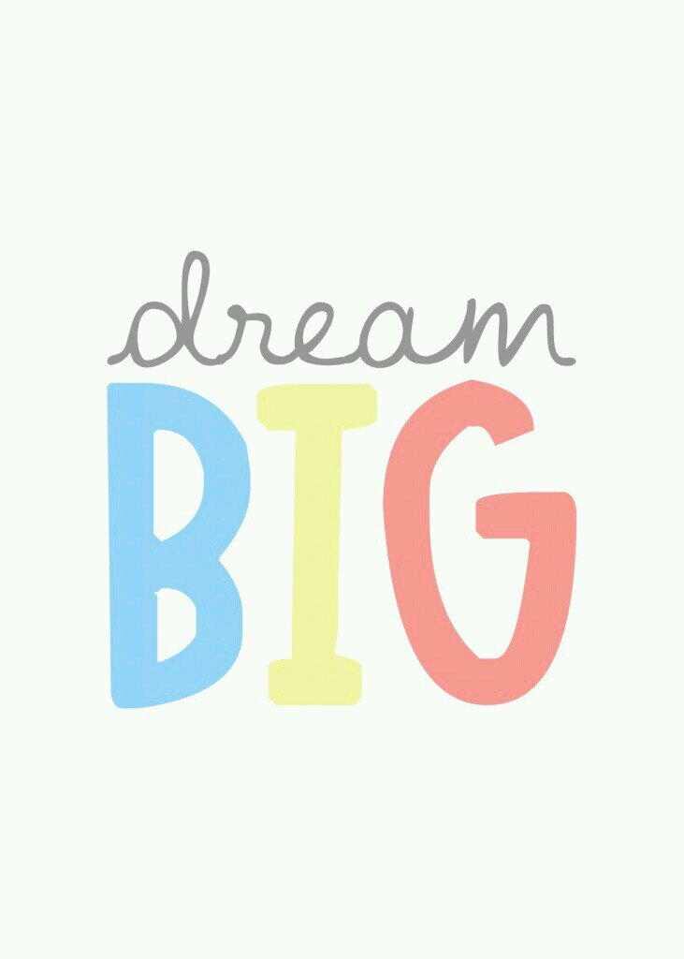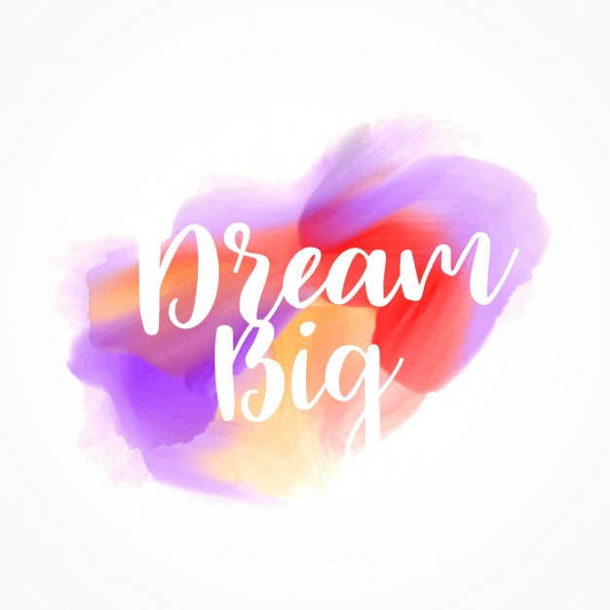



**Curriculum Information for Parents**

Class: Oak Term: Spring 2023-24