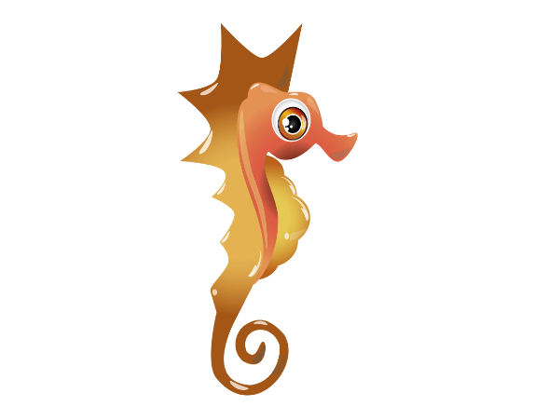

**Physical Development:**

* I can use my hands to manipulate playdough and tools.
* I can use a range of different media in provision to support fine motor skills.
* I can join in with finger gym activities
* I can begin to using mark making tools e.g. chalk, paintbrushes etc to make different shape and size marks
* I can investigate using my body in different ways- jumping, running, hopping, pushing, pulling etc
* I can negotiate space with increasing control

**Literacy-**

* I can use role play to explore stories
* I join in small group story time
* I am beginning to share my opinions about stories
* I can vote for a book I would like to hear read to me
* I will explore non-fiction books
* Texts – Owl Babies, Oliver’s Wood, Meg& Mog & Room on the Broom

**Communication & Language:**

* I know that in Autumn the leaves fall from the trees
* I can talk about celebrations within my family and other significant events.
* ​I can use new vocabulary to talk about Halloween, Bonfire Night and Christmas
* I will explore Halloween, Bonfire Night and Christmas through stories and provision

I can move in different ways from a start point to an end point. E.g. jumping, skipping, and hopping crawling… - linked to journeys

* 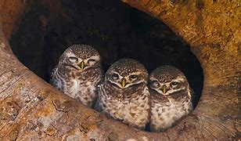

**Mathematics:**

* I can recognise how many objects I can see
* Practise counting through songs and rhymes I am beginning to count things I cannot see e.g. stones being dropped into a tin, bangs on a drum
* I can represent numbers through fingers and objects
* I can talk about shapes

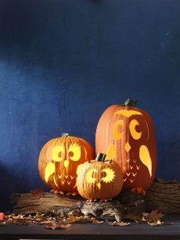

* 

**Understanding The World:**

* I can locate the North Pole– introduce a globe (Santa and the elves live)
* I can investigate ‘Santa’s parcels’ to see which are magnetic
* Bonfire night – safety story of Guy Fawkes
* I can join in making a firework in a jar
* I can join in a muddy puddle walk
* I know that Christmas comes after Halloween and that Halloween comes before Christmas
* I can retell the main points of the Christmas Story

**Nursery**–

**Autumn 2- 2022-23**

* 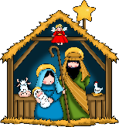

**Expressive Arts & Design:**

* I can sing and perform different Christmas songs
* I can listen to music and move my body
* I can make a bonfire picture
* I can use natural resources to make some transient art-faces
* I can make a salt dough Christmas decoration

**Personal, Social and Emotional Development: 3D PSHE Making Relationship- Lessons 40-Good Friends**

* I can follow the rules in Nursery
* I am beginning to demonstrate respect towards my friends, teachers and classroom environments.
* Introduce children to ‘DREAM BIG’ values
* I can talk about how my family takes care of me and how that makes me feel -linking with Owl Babies.