Thy



**Term Dates**

Spring Term 1 begins

Monday 8th January 2024

Break Up for February Half Term

Friday 19th February 2024

Spring Half Term 2 begins

Monday 20th February 2024

Break Up for Easter

Thursday 28th March 2024

Summer Term Begins Monday 15th April

Understanding The World

The children will continue to develop positive attitudes about the differences between people by learning about other cultures. We will learn about how Chinese New Year is celebrated.

The children will also learn about The Easter story.

We will explore the suitability of different materials when making models linked to, ‘The 3 Billy Goats and The 3 Little Pigs.’

We will learn about adult farm animal and match them to their babies- linked to Spring

**Home/ School Links**

Happy New Year! Welcome back to nursery for a new and exciting Spring Term.

Ideas to explore and investigate together will be sent home through Class Dojo. You can upload pictures of activities from home that support nursery topics to Class Dojo.

If you have any queries at any point, please don’t hesitate to come and speak to us or contact us through class Dojo.

Many Thanks for your continued support .Mrs Parkinson and Mrs Rogan

|  |  |  |
| --- | --- | --- |
|  | **Learning** | |
| Literacy | We will listen to and talk about stories daily to build familiarity and understanding. The children will be supported to answer questions about the stories we read with a focus on why questions, like: “Why did Elmer feel sad?” They will also be encouraged to talk about how characters feel and how they behave, E.g why the Rainbow fish didn’t want to share his scales? The children will be encouraged to look at books independently. In our reading area children have a range of story puppets and props and they will be supported to use them to act out and retell familiar stories and repeat familiar phrases from books.  **Focus Books This Term** - Spring 1 - Elmer, Rainbow Fish & Giraffes can’t dance Spring 2- Three Little Pigs, The 3 Billy Goats Gruff, Goldilocks, Little Red Riding Hood, The Gingerbread Man, Jack and the Beanstalk.  Younger children love listening to stories over and over again and you can help to support and encourage their enjoyment of books by sharing these and other stories with them at home regularly. | |
| Maths | This term we will continue reciting numbers to five and beyond and recognise and name these numbers. When counting small sets of objects, the children will learn that the last number reached tells them how many there are in total. We will link numerals and amounts by showing the right number of objects to match the numeral. The children will experiment with their own symbols and marks as well as numerals e.g. record how many balls they managed to throw through the hoop etc  We will talk about and identifies the patterns around us e.g. stripes on clothes, designs on rugs and wallpaper and confidently use words such as ‘stripy, spotty, zig zag, pointy’ etc. We will notice and correct an error in a repeating pattern.  We will make comparisons between objects relating to size, length, weight and capacity using the term big and small, empty and full, heavy and light. We will also continue to name common 2D shapes and talk about their properties. | |
| Communication and language | | The children will continue to develop listening and attention skills using the first 4 key elements of good listening: eyes looking, ears listening, mouth closed and hands nice and still. prompts eye looking, ears listening. The children will continue to be encouraged to share their thoughts/ideas and listen when their friends are talking. |
| Physical Development | | The children will continue to develop a comfortable grip and increased control when holding pens and pencils. They will explore writing patterns such as zig zag, swirls and letter shapes. The children will also practise writing their own name with the correct formation of letters. They will investigate using their body in different ways such jumping, running, hopping, pushing, pulling etc They will be supported to collaborate with others to build an outdoor (over, under and through) assault course to help develop co-ordination, balance, agility and the negotiation of space. |
| Personal Social and Emotional Development | | The children will develop vocabulary linked to emotions and use this to help them identify their feelings and the feelings of others. They will also consider how characters may feel. The children will be encouraged to independently choose where and what they want to play and to develop appropriate ways of being assertive. |
| Expressive Arts and Design | | The children will explore colour and colour-mixing. They will be supported to show different emotions in their drawings and paintings. They will also paint and draw characters from Traditional Tales. We will listen to the sounds of different instruments and the children will explore playing instruments to express different feelings and ideas. The children will use junk modelling, blocks and construction kits to make a model bridge for the 3 Billy Goats Gruff and the 3 Little Pig’s house. |

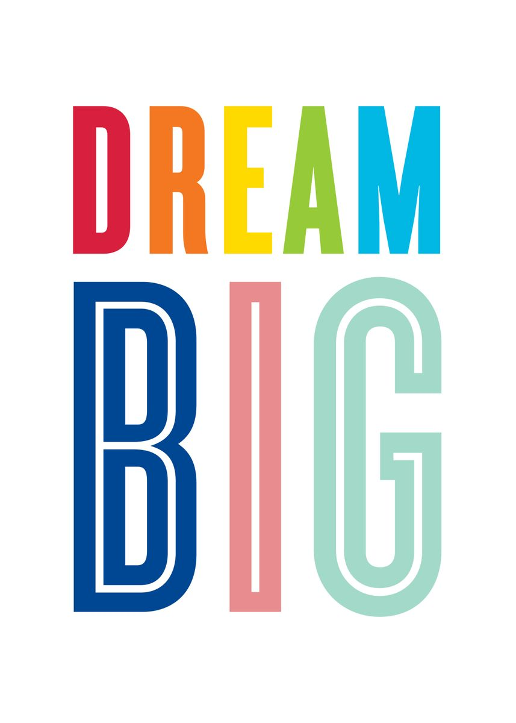



**Curriculum Information for Parents**

Class: Acorns Term: Spring 2024