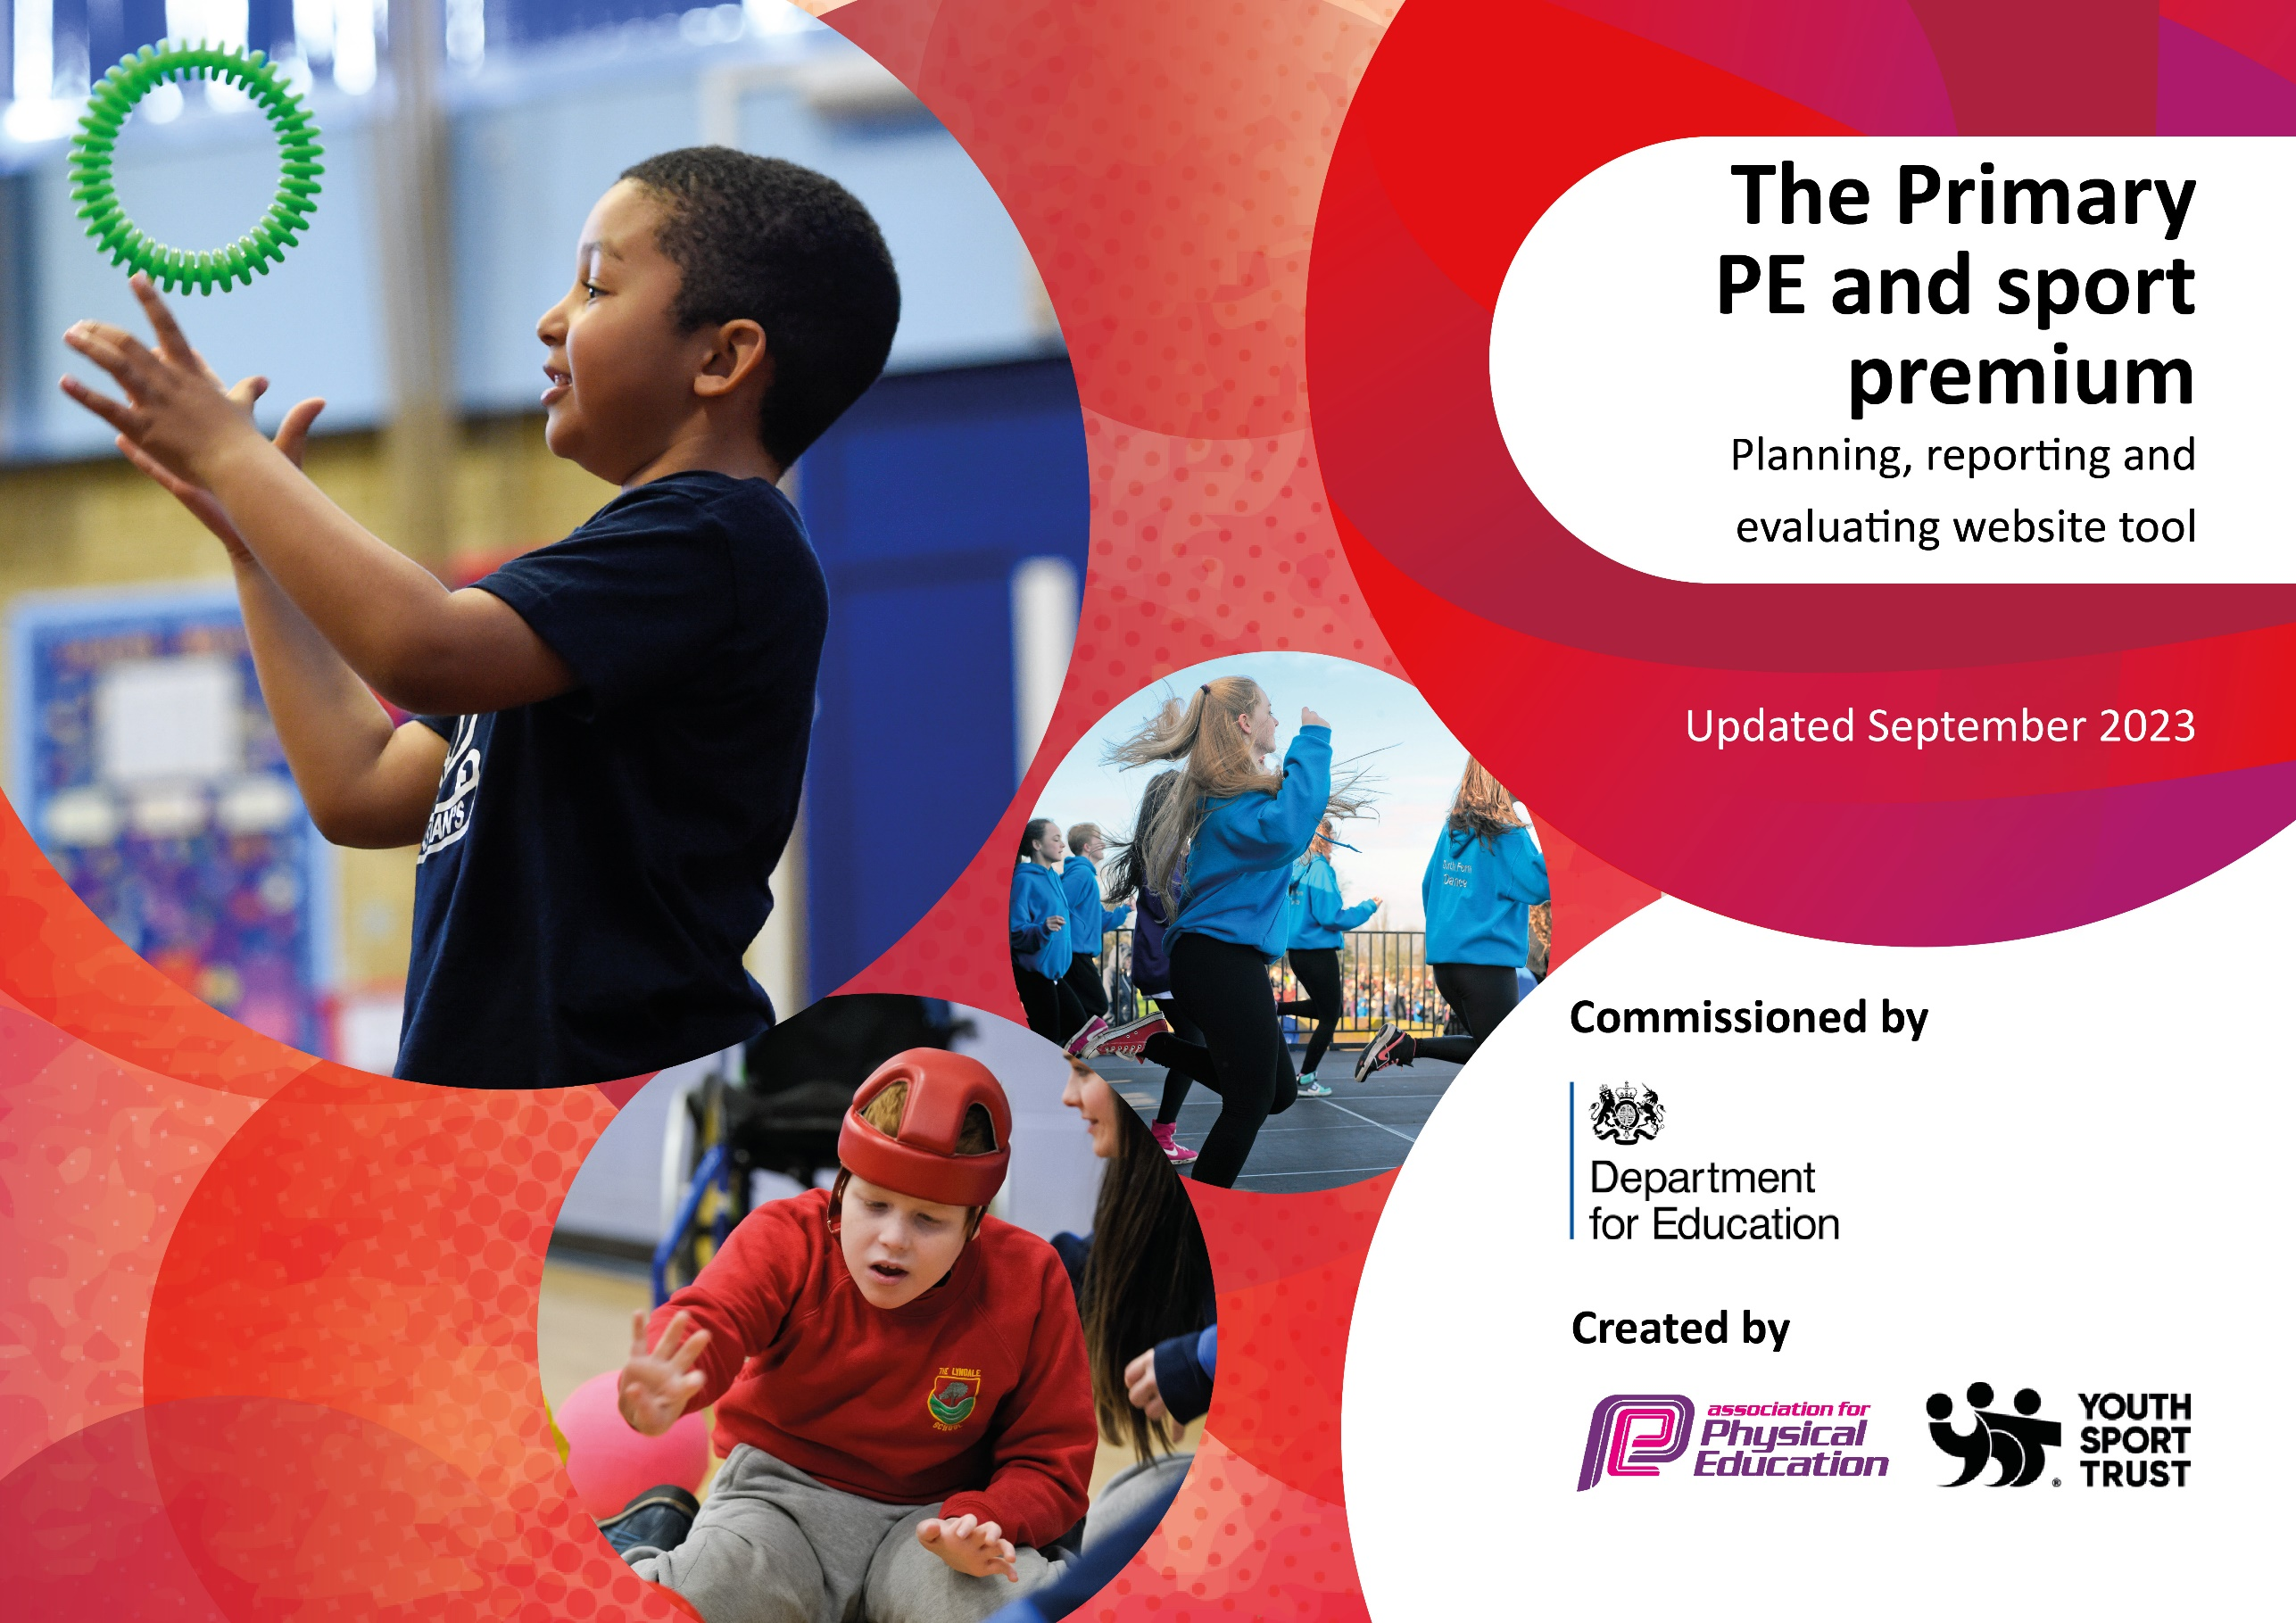

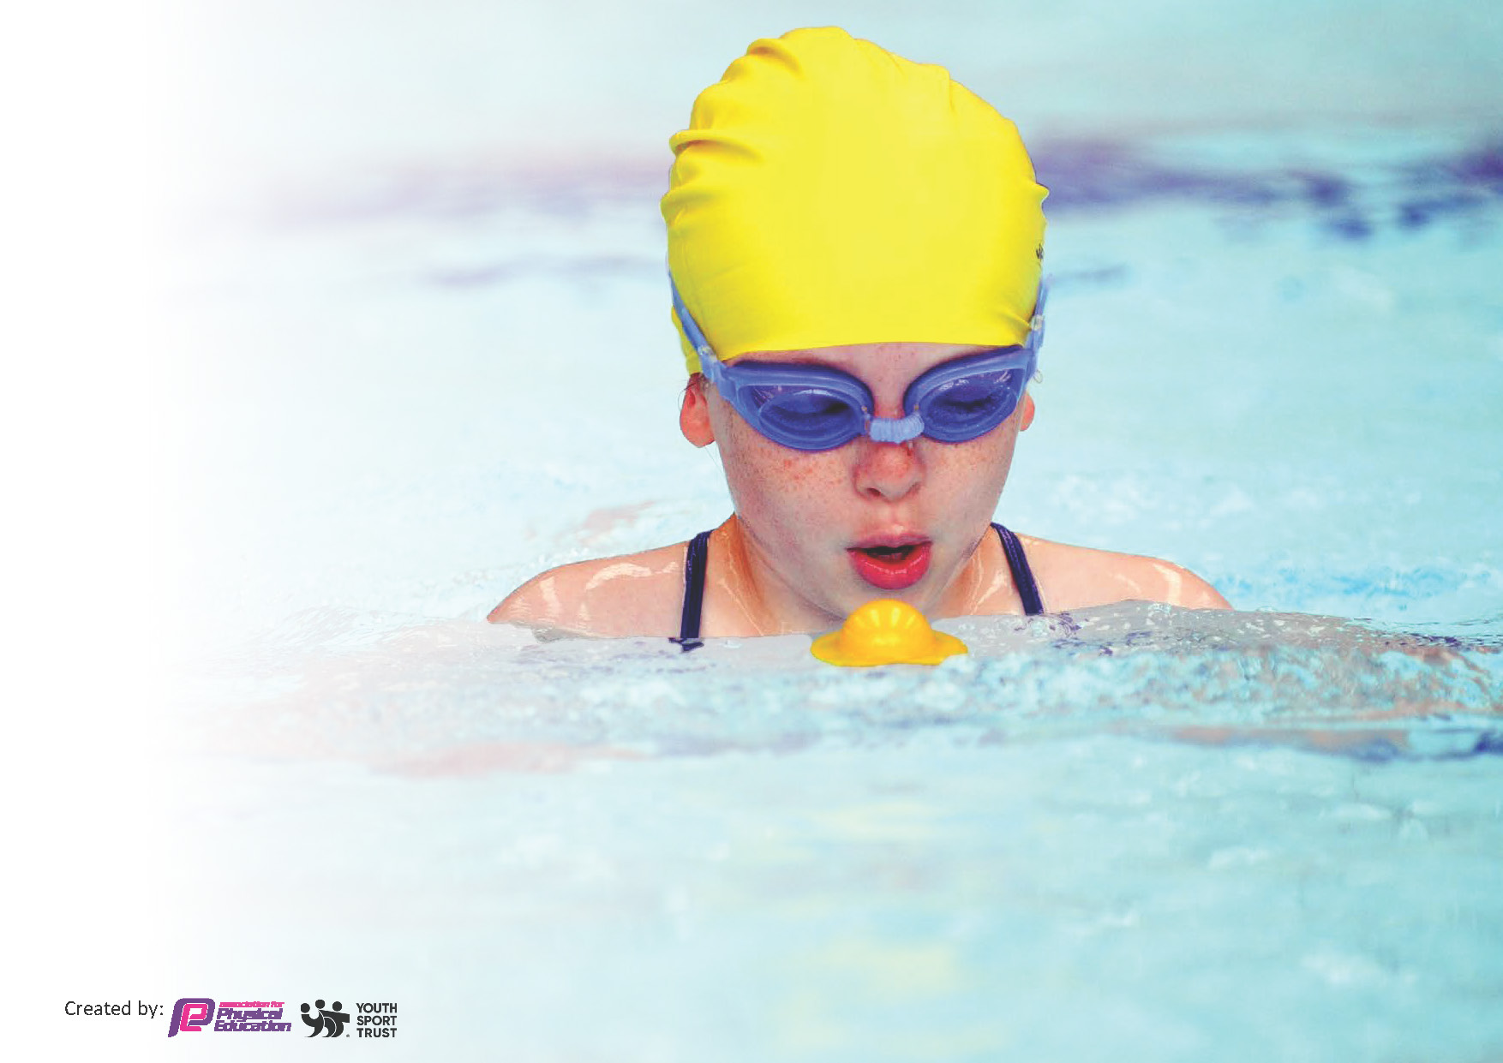
This template can be used for multiple purposes:
by:
- It enables schools to effectively plan their use of the Primary PE and sport premium
- It helps schools to meet the requirements (as set out in guidance) to publish information on their Primary PE and sport premium
- It will be an effective document to support Ofsted inspections enabling schools to evidence progress in Physical Education (PE) and evidence swimming attainment, which forms part of the PE National Curriculum. We would recommend schools consider
the Intent, Implementation and Impact of any spend, as examined within the Education Inspection Framework.

It is important that your grant is used effectively and based on school need.

Schools must use the funding to make additional and sustainable
improvements to the quality of the PE, School Sport and Physical Activity (PESSPA)
they offer. This means that you should use the Primary PE and sport premium to:

- Build capacity and capability within the school to ensure that improvements made now will benefit pupils joining the school in future years
- Develop or add to the PESSPA activities that your school already offers.

The Primary PE and sport premium should not be used to fund capital spend projects; the school’s core budget should fund these. Further detail on capital expenditure can be found in the updated Primary PE and sport premium guidance.

The Primary PE and sport premium guidance, outlines 5 key priorities that funding should be used towards. It is not

necessary that spending has to meet all the key priorities, you should select the priorities that you aim to use any funding towards.

Although completing this template is not a requirement for schools, schools are required to publish details of how they spend this funding. Schools must also outline what the impact this funding has had on pupils’ PE and sport participation and attainment and how any spending will be sustainable in the future. All funding must be spent by 31st July 2024.

The Department for Education has worked closely with the Association for Physical Education (afPE) and the Youth Sport Trust (YST) to develop this template and encourages schools to use it. This template is an effective way of meeting the reporting requirements of the Primary PE and sport premium.
Review of last year’s spend and key achievements (2022/2023)

We recommend you start by reflecting on the impact of current provision and reviewing your previous spend.

Activity/Action | Impact | Comments
Key indicator 1: The engagement of all pupils in regular physical activity  2 The profile of PESSPA being raised across the school as a tool for whole school improvement.  3 Increased confidence, knowledge and skills of all staff in teaching PE and sport  4 Broader experience of a range of sports and activities offered to all pupils  Key indicator 5: Increased participation in competitive sport | EITC delivered and trained a number of Year 5 children to be play leaders.  They now have a rota established with the support of the learning mentor.  A rota and resources have been established.  IQM – very happy with the progress made so far.  Ofsted happy with the progress too.  GYM further embedded and will be revisited next year by a key member of staff.  Whole school curriculum demonstrates progression and is well resources to ensure high quality lessons. Our EITC coach supports staff to develop their CPD through co teaching and targeted support.  Good quality curriculum funded via this money ensures that the curriculum is broad and balanced.  More children were able to access swimming due to this funding. Forest school will also continue to extend this.  Some better access to the use of a mini bus.  Good access to competition calendars via EITC and KSSP SLAs. | Train next years cohort in summer 2 in readiness for next year.  Everton in the Community continues to good value for money with impact beyond PE lessons.  Lesson visits are needed to fully evidence.  More MIDAS trained members of staff  More first aiders/ second adult.  More release from class to those who can drive

Key priorities and Planning
This planning template will allow schools to accurately plan their spending.

Action – what are you planning to do | Who does this action impact? | Key indicator to meet | Impacts and how sustainability will be achieved? | Cost linked to the action
CPD for teachers via Beth Tweddle Gymnastics and EitC  Provide staff and pupils with a high quality PE scheme of work and well resourced lessons  Embed lunchtime sport sessions/activities for pupils and further improve the playtime and lunchtime experience with resources to promote physical activity.  Use the breath of our SLA with Everton in the Community.  To provide children with the tools to support their self-regulation needs.  Allow a wider proportion of children to be able to access swimming lessons or water play.  Run and fund a Judo and Gymnastics extra-curricular club with specialist coaches  Children will take part in forest school activities in well-resourced sessions.  Children will participate in competitions. | Class Teachers and in turn, pupils.  Class Teachers and in turn, pupils.  Lunchtime supervisors / teaching staff, coaches - as they need to lead the activity  pupils – as they will take part.  Identified pupils  Pupils  Pupils  Pupils  pupils | KI 1: Increased confidence, knowledge and skills of all staff in teaching PE and sport.  KI 1: Increased confidence, knowledge and skills of all staff in teaching PE and sport.  KI 2 -The engagement of all pupils in regular physical activity  KI 3 - The profile of PE and sport is raised across the school as a tool for whole school improvement  KI 3 - The profile of PE and sport is raised across the school as a tool for whole school improvement  KI 4: Broader experience of a range of sports and activities offered to all pupils.  KI 4: Broader experience of a range of sports and activities offered to all pupils.  KI 4: Broader experience of a range of sports and activities offered to all pupils  KI 5: Increased participation in competitive sport. | With support from our EITC specialist coach and Beth Tweddle Curriculum support, teachers will be more confident to deliver effective PE and as a result improved % of pupil’s attainment in PE.  All staff will follow a high-quality, progressive whole-school curriculum.  Children will take part in lessons which are well resourced.  More pupils meeting their daily physical activity goal, more pupils encouraged to take part in PE and Sport Activities.  Utilise the features of our EITC SLA. I.e.  PHSE/Mentoring – targeting those identified via SG team or Learning Mentor.  Workshops - eg. Anti bullying/racism  Collapsed curriculum Days to promote whole school development or community needs.  Social action project - supporting a whole school or community issue  Sensory equipment will be available to those pupils who need help to self regulate. This will lead to less incidents of dysregulation and lost learning time.  Children from additional year groups and 2/3s of our DSP children will take part in swimming.  Children will have access to a bespoke extra curricula club.  Children will engage in learning beyond the classroom opportunities via forest school.  Staff will be available to accompany children to competitions.  Children will be able to attend competitions due to available transport and trained first aiders More MIDAS trained members of staff  More first aiders/ second adult.  More release from class to those who can drive | £6000 Everton in the Community SLA  Beth Tweddle Gym  Curriculum classes x 4 £1232 approx  £1650 GetSet4PE subscription (3 Year subscription – Year 1 of 3)  £600 – replenish PE Lesson equipment as needed.  £200 for top up of equipment  Part of £6000 Everton in the Community SLA  £1000 split between DSP and mainstream.  £3000  £800 approx.  £200 to replace and update resources.  £400

Key achievements 2023-2024
This template will be completed at the end of the academic year and will showcase the key achievements schools have made with their Primary PE and sport premium spending.

Activity/Action | Impact | Comments

Swimming Data
Meeting National Curriculum requirements for swimming and water safety.
Priority should always be given to ensuring that pupils can perform safe self-rescue even if they do not fully meet the first two requirements of the National Curriculum programme of study

Question | Stats: | Further context  Relative to local challenges
What percentage of your current Year 6 cohort can swim competently, confidently and proficiently over a distance of at least 25 metres? | 55% | Use this text box to give further context behind the percentage.  8 x 30 min sessions once per year.  Other 45% do not go swimming outside of these school sessions. Either before of after this input
What percentage of your current Year 6 cohort can use a range of strokes effectively [for example, front crawl, backstroke, and breaststroke]? | 55% | Use this text box to give further context behind the percentage.  For the 45%, building up from as little as 5m using a formal or informal stroke was a priority over the range of formal strokes.

What percentage of your current Year 6 cohort are able to perform safe self-rescue in different water-based situations? | 0% | Use this text box to give further context behind the percentage.  This was not taught due to limitations of the use of the pool. Year 6 only had access to the shallow end of the pool so it was not safe.
If your schools swimming data is below national expectation, you can choose to use the Primary PE and sport premium to provide additional top-up sessions for those pupils that did not meet National Curriculum  requirements after the completion of core lessons. Have you done this? | Yes | We already prioritise some SSP money to allow additional classes prior to Year 6.
Have you provided CPD to improve the knowledge and confidence of staff to be able to teach swimming and water safety? |  | The teachers do not teach the swimming lessons. All sessions are taught by very confident and experienced swimming instructors. Teachers are welcome to encourage the pupils. They observe and support.

Signed off by:

Head Teacher: | Rebecca O’Hanlon
Subject Leader or the individual responsible for the Primary PE and sport premium: | Clare Lynas
Governor: | Josie Gallagher
Date: | September 2023

