Yew Tree Primary Academy – Geography
Theme: Come Fly With Me 2 | Year Group : 2 | Phase: Key Stage 1 | Strand: Place knowledge, human and physical, geographical skills and field work
What should I already know?
- The town I live in is called Halewood.
- Halewood is in England, which is a country in the United Kingdom (England, Scotland Wales and Northern Ireland).
- There are seven continents, including Africa and Europe, and five oceans.
- UK is in the continent of Europe.
- Kenya is an example of a country that can be found in the continent of Africa
Vocabulary
airport | a place where aeroplanes land and take off
capital city | the city where the government sits. London is the capital city of England and the UK
city | a large town. London is a city. Liverpool is a city
climate | weather that is typical of a place
continent | a very large area of land that consists of many countries. Europe and Africa are continents.
country | an area of land that is controlled by its own government
farm | an area of land used to produce crops or to breed animals and livestock.
hill | a naturally raised area of land, which is not as high as a mountain.
hotel | a place that provides somewhere to sleep and eat for guests.
house | a building designed for people to live in.
Human features | features of land that have been impacted by human activity
humid | a climate that is very hot and damp
landscape | everything you can see when you look across an area of land, including hills, rivers, buildings, trees, and plants.
office | a building of rooms where business and work is carried out by office workers.
Physical features | natural features of land
rainfall | the amount of rain that falls in a time period
seasons | main periods of the year that can have their own weather conditions
skyscrapers | a very tall building with many floors
temperature | a measure of how hot or cold something is
tourist | a person who is visiting a place for pleasure and interest, especially when they are on holiday.
town | a large group of houses, shops and buildings where people live and work. Towns are larger than villages but smaller than cities. Halewood is a town.
train station | a place on a railway line where trains stop for people to get on and off trains.
vegetation | plants, trees and flowers
weather | the condition of the atmosphere in one area at a particular time, for example if it is raining, hot, or wind
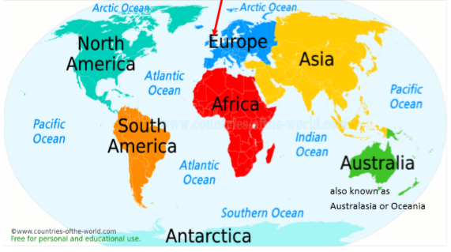

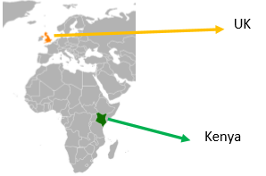
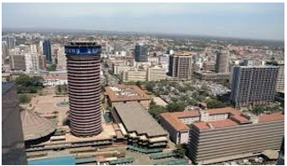

What should I know by the end of this theme?
- The United Kingdom is in Europe.
- Kenya is in Africa.
- Europe and Africa are continents.
- The United Kingdom and Kenya are countries.
- Both the UK and Kenya are made up of villages, towns and cities.
- Kenya is much larger than the UK.
- Kenya and the UK have different climates. This means that the weather is generally different.
- Nairobi is the capital city of Kenya.
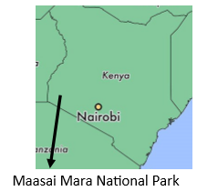

Human Geographical Features
- In Nairobi, people live in houses and apartments.
- There are tall buildings, which are called skyscrapers. The Times Tower is the most famous skyscraper in Nairobi. There are lots of offices in the Times Tower.
- Nairobi also has many parks, museums, shopping malls and supermarkets.
- There is also a train station and an airport.
- Many tourists visit Nairobi. This means that there are lots of hotels for them to stay in.
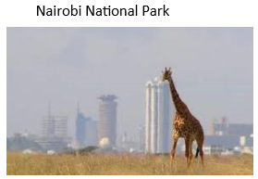
Physical Geographical Features
- The climate is warm and temperate in Nairobi but there is a significant amount of rainfall during the year. There is a wet season and dry season.
- Nairobi has many hills.
- There is a national park in Nairobi where there are giraffes and rhinos. The largest national park in Kenya is called the Maasai Mara Its animals include lions, cheetahs, elephants, zebras and hippos. It is a three hour drive away from Nairobi.

Literacy Tree Links
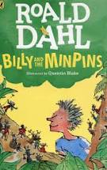

Geographical skills and field work
- Use aerial photographs to compare Halewood and Nairobi. What is the same? What is different?
- Use an atlas to find Kenya and the UK. Can you give instructions on how to use an atlas?
- If we could contact pupils in schools in Nairobi, what questions do you want to ask them? What can you tell them about Halewood?
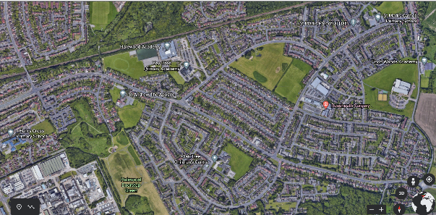
Aerial view of Halewood using Google Earth

