Yew Tree Primary Academy – Geography
Theme: Italy | Year Group : 3 | Phase: Key Stage 2 | Strand: (Locational Knowledge; Human & Physical Geography; Place Knowledge; Geographical skills and fieldwork)
What should I already know?
- Human features are a-made and physical features are natural.
- How to use an atlas to locate the UK and its countries – England, Wales, Scotland and Northern Ireland and their capital cities – London, Cardiff, Edinburgh and Belfast.
- There are 7 continents – Africa, Antarctica, Asia, Europe, North America, South America and Oceania.
- There are 5 oceans – Atlantic, Pacific, Indian, Southern and Arctic.
- Simple compass directions – north, east, south, west.
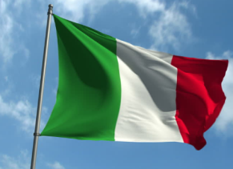
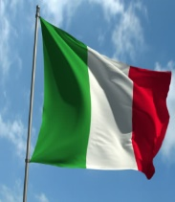
Italian Flag
1
Italian Flag

Vocabulary
atlas | a book of maps.
city | a large town. Liverpool is a city.
climate | the general weather conditions that are typical of a place.
coastal | an area of land close to the sea.
compass points | any of the main points of a compass: north, south, east, west, north-east, north-west, south-east, south-west.
continent | a very large area of land that consists of many countries. Europe is a continent.
country | an area of land that is controlled by its own government.
economic activity | the amount a country sells and makes.
equator | an imaginary line drawn around the middle of the earth an equal distance from the North Pole and the South Pole.
harbour | a sheltered port so that boats can be left there safely.
human features | features of land that have been impacted by human activity.
landscape | everything you can see when you look across an area of land, including hills, rivers, buildings, trees, and plants.
map | a drawing of a particular area such as a city, country or continent.
Mediterranean | southern areas of Europe which have mild winters and hot summers (e.g. Italy, Spain).
mountain | a very high area of land with steep sides.
peninsula | a piece of land which is almost completely surrounded by water.
population | the number of people living in a certain area.
physical features | natural features of land.
polar | northern Europe which is cold and dry all year.
port | a harbour area where ships load and unload goods or passengers.
river | a large, natural stream of fresh water that flows into the sea or a lake.
temperate | this middle section of Europe has cold winters and mild summers (e.g. U.K., Germany, Poland).
tourist | a person who is visiting a place for pleasure and interest, especially when they are on holiday.
trade | the activity of buying, selling or exchanging goods and services.
vegetation | plants, trees or flowers.
village | a small group of houses, perhaps with a few shops. Hale is a village.

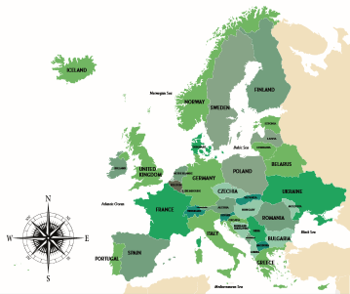
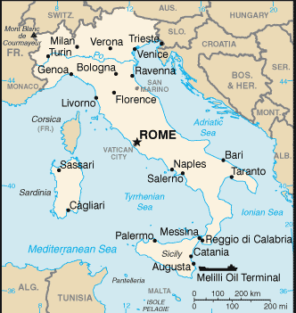
Map of Europe
Map of Italy
Map of Europe
Map of Italy

What Geographical Knowledge should I know by the end of this theme?
- There are 44 countries in Europe.
- There are 4 main climate types in Europe - Polar regions near the Arctic Circle, such as Iceland, Norway, Sweden, Finland and Russia, where tundra and icy glaciers are common; Temperate climates, much like the U.K. where there is rainfall and deciduous forests (trees which lose their leaves in the winter); Mediterranean climates, which are dry and hot and attract many tourists; Alpine climates, which are mountainous and cold.
- Italy is a Mediterranean country in southern Europe.
- Italy is a peninsula country (a piece of land that is surrounded by water on most sides but still connected to mainland).
- Aside from the mainland, Italy contains two large islands: Sicily and Sardinia, and many smaller islands.
- The capital of Italy is Rome.
- The Apennines mountain range runs north to south down the centre of the Italy.
- The longest river in Italy is the River Po, which is 670 km in length, and its source is in the Alps mountains to the north.
- Italy has higher mountains than the UK. Mt. Blanc is 4,807m high. The highest in the UK is Ben Nevis, at 1,345m.
- Our capital city, London, has a much larger population with 9,304,016 compared to Rome with 4, 257,000.
- Due to its more southerly position (closer to the Equator), Italy is warmer than the UK. On average, Rome is 7°C hotter than London.
- Italy is slightly larger than the UK – 301,340sq km compared to 243,610sq km.
- The UK has no active volcanoes, whereas Italy has three (Vesuvius, Etna, Stromboli).
- Some top human attractions in Italy are the Colosseum in Rome, Leaning Tower of Pisa, Grand Canal in Venice and Pompeii, whilst in the UK some human attractions are Stonehenge, Tower of London, Buckingham Palace, York Minster and Canterbury Cathedral.
- The population of Italy is smaller than the UK at 60, 461,826 (2020) compared to 67, 886, 011.Turin’s population is larger with 1,792,000 compared to 902,000 in Merseyside.
- Merseyside and Turin are both situated close to rivers - the River Mersey and the River Po.
- Turin is on higher ground at 239m above sea level compared to more low-lying Merseyside at 45m. Turin does have flatter plains of land.
- Merseyside has dense settlements of housing and industry, like Turin. Very good road and rail transport links in both regions. Close to ports.
- Car manufacturing locally in Halewood at Jaguar and Fiat in Turin. Tourism supports the economy in both regions.
- Climate is cooler in Turin than rest of Italy, with cool summers and winters; Merseyside has warm summers and cool to cold winters.

What Geographical skills will I have learnt by the end of this theme?
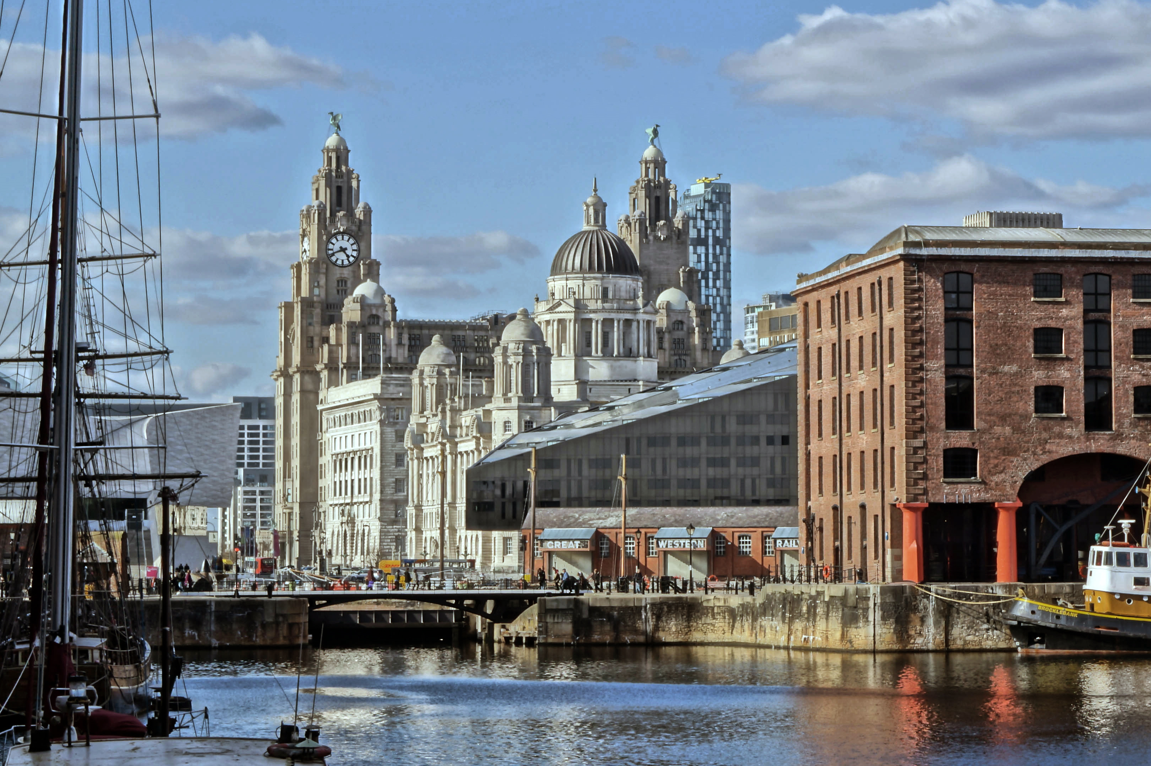
- Use an atlas to identify and label the countries and capital cities in Europe on a map.
- Use an atlas to identify and label the main rivers and mountain ranges in Europe.
- Identify areas of flat and mountainous land using a physical map of Europe.
- Identify the position and significance of latitude, longitude, Equator, Northern Hemisphere, Southern Hemisphere, Arctic and Antarctic Circle, the Prime/Greenwich Meridian and time zones.
- Use a map, Digimap and atlas to find Italy and Merseyside.
- Locate key rivers, mountains and volcanoes in Italy.
- Briefly compare similarities and differences in physical and human geography between UK and Italy, using aerial photographs and various maps.
- Use aerial photographs and digital maps to compare Merseyside in the North West region of the UK and Turin in the Piedmont region of Italy in Europe. What is the same? What is different?
- Use OS maps and digital maps to identify settlement and land use in Merseyside and Turin.
- Analyse different types of maps and graphs that give us information about Merseyside and Turin, including climate graphs.
- Create a Venn diagram to compare similarities and differences between Merseyside and Turin.
Literacy Tree Links

