Yew Tree Primary Academy

Music Progression of Skills

Development Matters - EYFS

Kapow Primary – Years 1 - 6

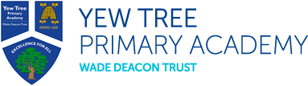

EYFS Curriculum - Expressive Arts and Design
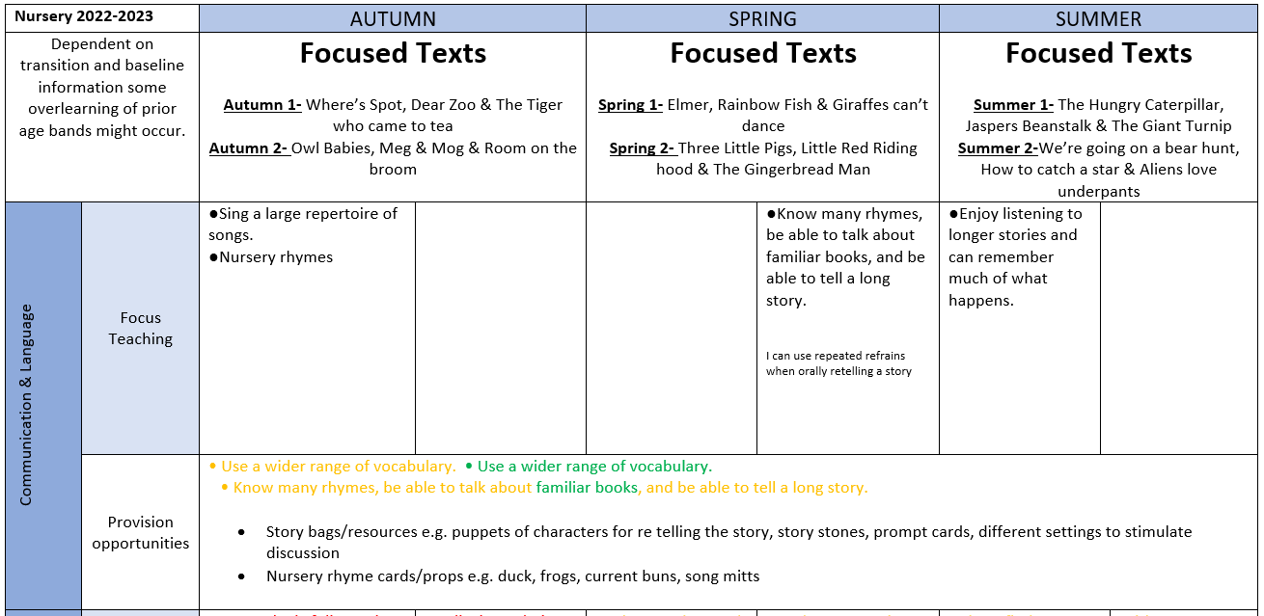

EYFS Curriculum – Communication and Language

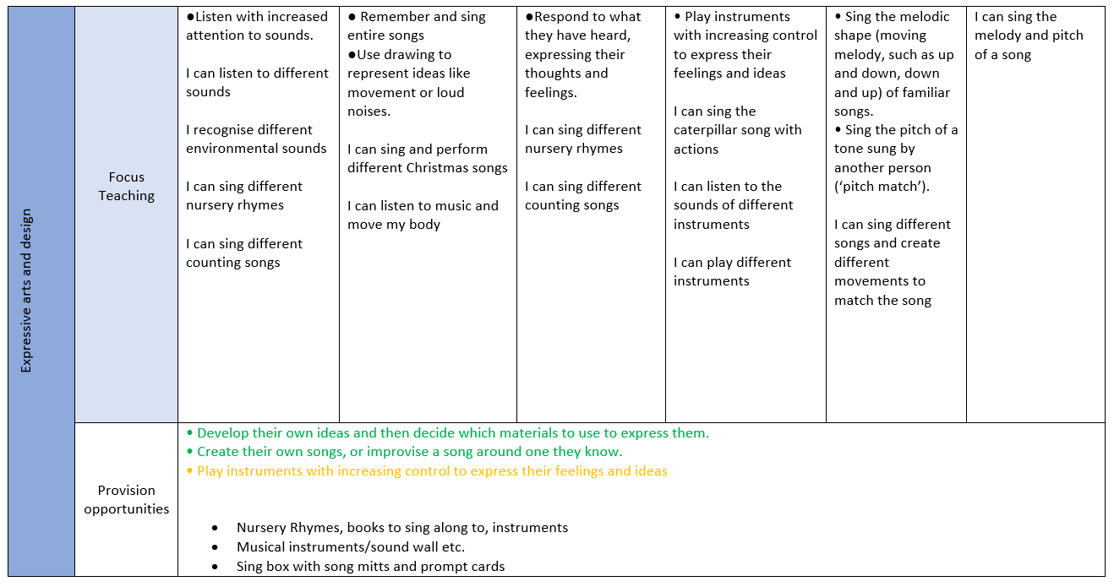

Reception 2022-2023 | AUTUMN | SPRING | SUMMER
Dependent on transition and baseline information some overlearning of prior age bands might occur. | Focused Texts  Autumn 1 – Goldilocks and the Three bears, Little Red Riding Hood  Autumn 2 – The Leaf Thief, The Gruffalo, The Gruffalo’s Child & Naughty Bus | Literacy Tree Focused Texts  Spring 1 – I’m Henry Finch & Weirdo  Spring 2 – Little Red & Super Milly | Literacy Tree Focused Texts  Summer 1 – The Tiny Seed & The extraordinary gardener  Summer 2 – Look Up & The Night Pirates
